🩸 FOTABO HASHI
Project Documentation

Made BY:
MD. Shoaib Sikder

Contents
1. Executive Summary 5
Main Value Proposition 5
Technology Stack 5
Current Implementation Snapshot 5
2. Introduction 6
2.1 Project Background 6
2.2 Project Objectives 6
2.3 Stakeholders and User Classes 6
2.4 Scope 6
2.5 Constraints 6
3. Scenario Writing 7
Scenario-1: User Registration 7
Scenario-2: User Login / Role Routing 7
Scenario-3: Session Restore / Logout 7
Scenario-4: Profile Viewing / Editing 7
Scenario-5: Donor Availability Update 7
Scenario-6: Donor Search 7
Scenario-7: View Donor Contact 7
Scenario-8: Create Blood Request 7
Scenario-9: Browse / Filter Requests 8
Scenario-10: View / Edit Own Request 8
Scenario-11: Fulfill / Cancel Request 8
Scenario-12: Submit Donation Count for Review 8
Scenario-13: Admin Records Verified Donation 8
Scenario-14: Admin Reviews Donation Count 8
Scenario-15: Leaderboard 8
Scenario-16: Notifications 8
Scenario-17: Admin Dashboard / Health 8
Scenario-18: Admin User Management 8
Scenario-19: Admin Blood Request Management 9
Scenario-20: Admin Public Content Management 9
Scenario-21: Admin Audit 9
Scenario-22: API / Service Failure 9
4. Requirement Specification 9
4.1 Functional Requirements (FR) 9
4.2 Non-Functional Requirements (NFR) 10
5. System Design & Architecture 11
5.1 System Architecture Diagram 11
5.1.1 Admin Control and Monitoring Architecture 12
5.2 System Modeling 12
Use Case Diagram 12
Admin Control Use Case Diagram 13
Activity Diagrams 14
Scenario-1: User Registration / Login / Role Routing 14
Scenario-2: Donor Search 15
Scenario-3: Blood Request Creation and Lifecycle 16
Scenario-4: Member Donation Count Review 17
Scenario-5: Administrator Records Verified Donation 18
Scenario-6: Notice and Notification Workflow 19
Sequence Diagram 20
5.3 Database Design 20
Entity Relationship Diagram (ERD) 21
Data Dictionary 21
User Table 21
Profile Table 21
BloodRequest Table 22
DonationRecord Table 22
DonationCountReview Table 22
Notification Table 22
AuditLog Table 23
OrganizationInformation Table 23
Notice Table 23
FoundingMember Table 23
Database Integrity Rules 24
6. Technical Implementation 24
6.1 Backend / Data Interaction Documentation 24
6.1.1 Backend Organization 24
6.1.2 RESTful API Endpoints 24
6.1.3 API Request / Response Conventions 26
6.1.4 Authentication and Session Rules 26
6.1.5 Donor Search Implementation 26
6.1.6 Blood Request Lifecycle 26
6.1.7 Donation Verification and Leaderboard 27
6.1.8 Notification Rules 27
6.1.9 Admin Control and Monitoring 27
6.1.10 Media Handling Rules 28
6.1.11 Database RLS, Cache, Rate Limits and Monitoring 28
6.2 Relationship & Access Rules 28
6.3 Frontend Organization 28
6.3.1 Public Frontend Organization 29
6.3.2 Member Frontend Organization 29
6.3.3 Frontend Design and Style 29
6.3.4 Current UI / User-Target Gap Register 30
6.4 Administration Frontend Organization 30
7. Quality Assurance & Testing 30
7.1 Test Case Scenarios 31
7.1.1 Repository Test Coverage Inventory 32
7.2 Requirements Traceability Matrix (RTM) 33
8. Individual Contribution 33
Technical Challenges 33
Learning Outcomes 34
9. Conclusion & Future Work 34
9.1 Conclusion 34
9.2 Future Enhancements / Version 2.0 34
9.3 Explicitly Not Implemented in Current Repository 34
10. Appendices 35
Appendix A: Project Repository and Deployment References 35
Appendix B: Backend Setup (Repository README Workflow) 35
Appendix C: Frontend Setup 35
Appendix D: Production Deployment Summary 35
Appendix E: Environment Variables and Secret Handling 36
Appendix F: Repository UI Screenshot Inventory 36
Appendix G: Repository Checks and CI Workflow 36
Appendix H: Key Repository Modules 37
Appendix I: Known Gaps and Decisions for Project Owner 38
Appendix J: Glossary 38
Appendix K: Verification Statement 38

1. Executive Summary
Fotabo Hashi is a bilingual blood-donation and community-support web platform. It connects people who need blood with registered donors and provides organized workflows for donor discovery, blood-request management, verified donation activity, public notices and administrator oversight. The current system is a React single-page application supported by a versioned Django REST API. PostgreSQL stores application data; Redis supports production caching and throttling; Supabase Storage stores active-member photographs; and Resend is configured for account email delivery.

Main Value Proposition
- For members and donors: maintain a profile, indicate donor availability, search available donors by blood group/location/search term, create and manage blood requests, view request summaries, see verified donation rankings and receive in-app notifications.
- For requesters: publish a request with blood group, required units, location and optional description; follow its ACTIVE, FULFILLED or CANCELLED state.
- For administrators: manage accounts, record verified donations, review self-reported donation-count changes, manage blood requests and public content, inspect audit events and monitor platform health.
- For the organization: publish its organization details, notices and active/founding-member records and present a bilingual public identity.

Technology Stack
Layer | Repository technology
Frontend | React 18.3, Vite 6, React Router 7, Tailwind CSS 3, Lucide React
Backend | Python 3.13, Django 5.2, Django REST Framework
Authentication | Simple JWT, HttpOnly access/refresh cookies, CSRF protection; Bearer JWT accepted as compatibility fallback
Database | PostgreSQL; hosted deployment uses Supabase PostgreSQL
Cache / throttling | Redis, django-redis; local-development in-memory cache option
Media | Django storage adapter; local filesystem in development and Supabase Storage in production
Email | Resend for password-reset/account email delivery
Hosting | Vercel frontend, Render API + Redis
Quality | pytest, Ruff, Black, pip-audit, ESLint, npm audit, Vite production build, OpenAPI schema validation

Current Implementation Snapshot
Area | Verified current implementation
Public routes | Home, Login, Register, Forgot Password and Reset Password; About, active-member and notice sections are rendered within Home.
Member routes | Dashboard, Donor Search, Requests, Create Request, Request Details, Leaderboard, Profile and Settings.
Admin routes | Dashboard, Users, Donation Reviews, Requests, Public Content and Audit.
Account roles | USER and ADMIN. Public pages do not require an account.
Blood groups | A+, A-, B+, B-, AB+, AB-, O+, O-.
Request statuses | ACTIVE, FULFILLED, CANCELLED.
Verified donations | DonationRecord rows and Profile.approved_donation_count feed the leaderboard.
Mobile navigation | Member bottom navigation currently has Dashboard, Donors, Requests and Leaderboard; Settings/Profile are in desktop sidebar and accessible elsewhere.
Dashboard difference | Current dashboard displays avatar initials, name, role and contact/profile values, followed by request/profile/donor metrics; it does not show the approved donation count in the first identity card.
Profile image difference | Member profile image upload is explicitly disabled by ProfileSerializer. Avatars are generated from a name/email fallback; only public active-member images use object storage.

2. Introduction

2.1 Project Background
Blood-donation coordination can rely on fragmented messages and manual searching. Fotabo Hashi provides a structured directory of members who have marked themselves available to donate, a request registry and an administrative process for confirming donations. Its role is coordination and information management; it is not a medical eligibility system, clinical triage tool or guarantee that a request will be fulfilled.

2.2 Project Objectives
- Provide a bilingual public-facing website with organization details, hero content, active-member listings and notices.
- Allow email-based registration, login, logout, password reset and password change with secure browser session handling.
- Maintain a member profile with blood group, phone, location, donor-availability state and donation-count declarations.
- Allow authenticated users to search the available donor directory using blood group, location and search term filters.
- Allow authenticated members to create, view, update, fulfill and cancel their own blood requests under server-enforced rules.
- Calculate a leaderboard using administrator-approved completed-donation counts rather than self-reported counts or request counts.
- Provide in-app notification list/read states and a distinct administrator workspace.
- Provide administrator controls for accounts, verified donations, count reviews, requests, public notices, active members and audit activity.
- Use PostgreSQL Row-Level Security, backend permissions, throttling, request IDs, standardized API responses and secure storage configuration.
- Support the repository’s deployment and CI checks using Vercel, Render, Supabase, Redis and Resend.

2.3 Stakeholders and User Classes
Stakeholder / role | Responsibilities / interests
Public visitor | Read organization information and notices; view active-member information; reach registration/login.
USER member / donor | Maintain profile, donor availability, search donors, create/manage own requests, review verified donation count, leaderboard and notifications.
ADMIN | Manage accounts and roles; record verified donation events; approve/reject donation-count reviews; manage requests and public content; inspect audit activity.
Organization operator | Supply accurate organization text, slogans, notices, active-member content and public contact details.
Project owner / developer | Architecture, implementation, database and API design, security, deployment, quality and maintenance.

2.4 Scope
In scope: public content, accounts, profiles, donor search, blood requests, donation records and count-review workflows, leaderboard, notifications, administration, audit, database security, storage, deployment and test automation found in the repository.
Not found in the reviewed source as implemented features: in-app donor-to-requester messaging/contact request, hospital/recipient-specific medical records, request needed-by datetime, profile photo upload, donation certificates, campaigns, volunteers, appointment booking, real-time WebSocket delivery, or separate About/Services/Founders/Notices routes. Do not imply those features exist.

2.5 Constraints
- The active implementation is a browser-based React SPA; frontend route guards are not a security boundary.
- Development and production settings require a Supabase PostgreSQL DATABASE_URL; the README explicitly states there is no local database fallback for normal development/production settings. CI uses a disposable PostgreSQL service in testing settings.
- Production storage is Supabase Storage; the service-role credential is backend-only.
- Production requires HTTPS origins, CORS and CSRF configuration, Supabase Storage and Resend sender configuration.
- The repository documentation’s deployment topology uses Render Oregon and a Supabase PostgreSQL US-West region, as recorded in README and Render blueprint; these are deployment configuration choices rather than universal system requirements.

3. Scenario Writing

Scenario-1: User Registration
A visitor opens /register, enters name, email, phone, blood group and password, and confirms the password in the browser. The API validates email uniqueness, required phone, blood group and Django password rules. On success it creates the account/profile, sets HttpOnly access and refresh cookies and returns the user identity.

Scenario-2: User Login / Role Routing
A visitor submits email, password and optional remember_me. The frontend obtains a CSRF token; Django validates the credentials and active account, sets access/refresh cookies and returns role data. USER routes to /dashboard; ADMIN routes to /admin/dashboard.

Scenario-3: Session Restore / Logout
On startup AuthContext calls /auth/me/. If there is a valid cookie it restores user identity; expired access can trigger one refresh attempt through the API client. Logout calls /auth/logout/, blacklists refresh token when present, clears cookies and clears client-side user/cache state.

Scenario-4: Profile Viewing / Editing
A signed-in user opens /profile. The page loads /profile/me/ and displays name, email, phone, blood group, location, donor availability, self-reported donation count, approved donation count and review status. The user may update editable profile fields. Profile photo upload is rejected.

Scenario-5: Donor Availability Update
A member checks or unchecks “Available to donate”. Profile update changes is_available_for_donation. The donor directory includes only Profile records marked available.

Scenario-6: Donor Search
An authenticated member opens /donors and supplies search text and/or blood group. The frontend sends page and page_size=20. Django filters available profiles by name, location, blood group and selected blood-group filter, and returns paginated results.

Scenario-7: View Donor Contact
A search result displays donor name, blood group, phone and location. If phone is present, the UI offers a tel: link. This contact exposure is current behavior and should be governed by the organization’s consent/privacy policy.

Scenario-8: Create Blood Request
An authenticated member opens /requests/new and provides blood_group, required_units, location and optional description. The API assigns requester from the authenticated session (ignores a client-supplied requester), validates positive units and non-empty location, creates ACTIVE request and notifies active administrators.

Scenario-9: Browse / Filter Requests
A member opens /requests, searches and filters by blood group/status. Django filters records using blood group, status, location and description search, and returns 20 per page by default.

Scenario-10: View / Edit Own Request
The request detail page fetches /blood-requests/{id}/. The API returns requester_name and is_owner. When the user owns an ACTIVE request, the UI offers editing. Backend ownership check rejects non-owner updates; the service rejects edits after the request leaves ACTIVE.

Scenario-11: Fulfill / Cancel Request
The owner chooses Mark Fulfilled or Cancel Request. The UI asks for confirmation and POSTs to /fulfill/ or /cancel/. Only an owner may perform the action, only ACTIVE requests may transition, and a repeated/invalid transition is rejected.

Scenario-12: Submit Donation Count for Review
A member changes self_reported_donation_count on profile. The service supersedes any pending review and creates a new DonationCountReview when requested count differs from approved count, then notifies administrators. The approved count remains unchanged pending review.

Scenario-13: Admin Records Verified Donation
An administrator opens a user record and records donated_on and optional notes. The service writes a DonationRecord, increments approved_donation_count, blocks duplicate donor/date records, creates an audit entry and notifies the donor.

Scenario-14: Admin Reviews Donation Count
An administrator filters pending count-review records and approves or rejects a review. Approval updates Profile.approved_donation_count to requested_count; rejection leaves approved count unchanged. Review status, reviewer and reviewed_at are updated; audit and member notification are written.

Scenario-15: Leaderboard
An authenticated member opens /leaderboard. Backend ranks active USER accounts with approved_donation_count > 0, uses DenseRank by donation count, and returns at most 100 entries.

Scenario-16: Notifications
A member opens notification center/list. API returns only records where recipient=current user. The user marks one item read or marks all read. Ownership is enforced by filtering notifications to the authenticated recipient.

Scenario-17: Admin Dashboard / Health
An administrator opens /admin/dashboard. Frontend reads admin overview metrics and recent audit events; separately checks readiness. The overview includes users, active users, available donors, total/active blood requests, audit events and recent-seven-day values.

Scenario-18: Admin User Management
Administrator searches/filter users by role, active state, text, name, email, phone, blood group or donation-count difference. Admin may create/update/delete permitted accounts. The service prevents an admin from deleting self and prevents disabling/demoting/deleting the last active admin.

Scenario-19: Admin Blood Request Management
Administrator lists and filters requests and may create, update or delete records. Changes are recorded in the audit log, relevant caches are invalidated and request owners are notified when status changes.

Scenario-20: Admin Public Content Management
Administrator creates/edits/deletes notices and active-member records. Publishing a notice sets published_at, invalidates public cache and fans out ANNOUNCEMENT notifications to active USER accounts. Active-member image uploads are validated and stored by the configured storage backend.

Scenario-21: Admin Audit
An administrator opens audit activity. The endpoint supports action/resource_type filters and a recent limit from 1 to 20. The API exposes actor email, action, resource, description and timestamp; it deliberately omits IP address, user agent and metadata.

Scenario-22: API / Service Failure
If the API is unavailable, the frontend displays a loading/error or empty state according to the page. The API returns a stable error envelope and request ID; health readiness reports dependency status. The frontend must not claim failed writes succeeded.

4. Requirement Specification

4.1 Functional Requirements (FR)
FR ID | Feature | Requirement
FR-01 | Public Home | The system shall provide a public home route with hero content and navigation to the available public sections and authentication pages.
FR-02 | Organization Information | The system shall expose organization name, slogan, description, address, email and phone to public visitors.
FR-03 | Public Notices | The system shall list only published notices and render title, content and publication date.
FR-04 | Active Members | The system shall display published active/founding-member records with name, designation, social URL and optional image.
FR-05 | Registration | The system shall register accounts using email, name, phone, blood group and password with server-side validation.
FR-06 | Login | The system shall authenticate using email/password and return role-aware session identity.
FR-07 | Cookie Session | The system shall issue, refresh, blacklist and clear HttpOnly access/refresh cookies and apply CSRF verification to cookie-authenticated unsafe requests.
FR-08 | Password Reset | The system shall issue password reset emails and confirm resets using UID/token/new password.
FR-09 | Password Change | An authenticated member shall change the password after supplying current and new passwords.
FR-10 | Own Profile | A member shall view and update their own name, phone, blood group, location and donor availability.
FR-11 | Donation Count Self-Report | A member shall submit a self-reported donation count; a change from approved count shall be routed to admin review.
FR-12 | Donor Availability | The system shall include only profiles marked available for donation in the donor search queryset.
FR-13 | Donor Search | Authenticated members shall search donors using search text, blood group, location and name filters with pagination.
FR-14 | Donor Detail / Contact | The system shall return donor name, blood group, phone, location and availability to authenticated donor-search clients.
FR-15 | Create Blood Request | An authenticated member shall create a request containing blood group, positive required units, non-empty location and optional description.
FR-16 | List / Filter Requests | Authenticated members shall list and filter requests by search, blood group, status and location.
FR-17 | Request Summary | The system shall return the current member’s total, active, fulfilled counts and up to five recent requests.
FR-18 | Request Ownership | A member shall update, fulfill or cancel only their own request.
FR-19 | Request Status Rules | A request shall begin ACTIVE and only an ACTIVE request may be fulfilled or cancelled; status cannot be supplied directly by a normal user update.
FR-20 | Donation Records | An administrator shall create and remove verified donation records for a USER account; duplicate donor/date entries and future dates shall be rejected.
FR-21 | Donation Count Reviews | Administrators shall list pending count-change reviews and approve/reject each pending record.
FR-22 | Leaderboard | The system shall rank active USER members using approved donation counts and return at most 100 ranked entries.
FR-23 | Notifications | The system shall create event notifications and list only notifications belonging to the authenticated recipient.
FR-24 | Notification Read State | A member shall mark an owned notification or all own notifications as read.
FR-25 | Admin Overview | Administrators shall view platform metrics and recent audit activity.
FR-26 | Admin User Management | Administrators shall search, create, update and delete accounts with last-active-admin protections.
FR-27 | Admin Request Management | Administrators shall create, inspect, update and delete blood requests.
FR-28 | Admin Content Management | Administrators shall create/update/delete notices and active-member records.
FR-29 | Audit Logging | Sensitive account, donation, request and public-content operations shall create attributable audit records where implemented.
FR-30 | API Health / Readiness | The API shall expose health, liveness and readiness endpoints.
FR-31 | Localization | The frontend shall provide English and Bangla translations for the implemented common, public, dashboard, donors, requests and settings dictionaries.
FR-32 | Role-Aware UI | The frontend shall provide distinct public, member and admin route groups and navigation shells.
FR-33 | Pagination | List APIs shall use standardized page-number pagination, default 20 and maximum page_size 100.
FR-34 | API Error Contract | The API shall return a standardized error structure with code, message, details and request identifier when available.

4.2 Non-Functional Requirements (NFR)
NFR ID | Requirement
NFR-01 Security | Use secure password validation, HttpOnly cookies, CSRF, HTTPS production enforcement, server-side role/object permissions and least-privilege secrets.
NFR-02 Database isolation | Apply PostgreSQL Row-Level Security on protected tables; set request-scoped identity context and clear it before pooled connections are reused.
NFR-03 Privacy | Restrict notifications to their recipient; omit sensitive audit IP/user-agent/metadata from the admin list serializer; review donor phone/location exposure under organizational policy.
NFR-04 Reliability | Use transactions for donation record and review transitions; enforce unique donor/date and single pending review constraints.
NFR-05 Performance | Paginate lists, index donor/request search fields, cache public content/admin overview and invalidate cached values after writes.
NFR-06 Throttling | Apply anonymous/user and action-specific rate limits; production caching uses Redis and throttle classes fail open if cache is unavailable as configured.
NFR-07 Maintainability | Separate Django domains, serializers, selectors, services, routes and tests; separate frontend feature pages, shared components, contexts and API services.
NFR-08 Compatibility | Frontend CSS sets min-width 320px; current UI uses responsive Tailwind breakpoints and touch controls; browser/device verification remains a release task.
NFR-09 Accessibility | Use semantic labels, keyboard-accessible controls, visible focus, aria labels and reduced-motion CSS where implemented; conduct manual assistive-technology review before release.
NFR-10 Localization | Use English and Bangla dictionaries and set document language from selected locale; verify untranslated strings and long Bangla text across all routes.
NFR-11 Observability | Attach X-Request-ID, JSON production logs, health/liveness/readiness checks and optional Sentry error reporting.
NFR-12 Deployment security | Production requires HTTPS origins, secure cookies, Supabase Storage, verified Resend sender and server-only environment secrets.
NFR-13 Media safety | Validate active-member uploads for JPEG/PNG/WebP, configured size (default 5 MB) and dimensions (<=5000px); never expose storage service-role key.
NFR-14 Backup and recovery | Provide documented encrypted off-server PostgreSQL backup settings and retention values; backup execution/restore evidence must be verified operationally.
NFR-15 Cost / hosting | Use the documented Vercel/Render/Supabase/Redis deployment model; verify actual provider plan, quotas, backups, persistence and cold-start behavior at release.

5. System Design & Architecture

5.1 System Architecture Diagram
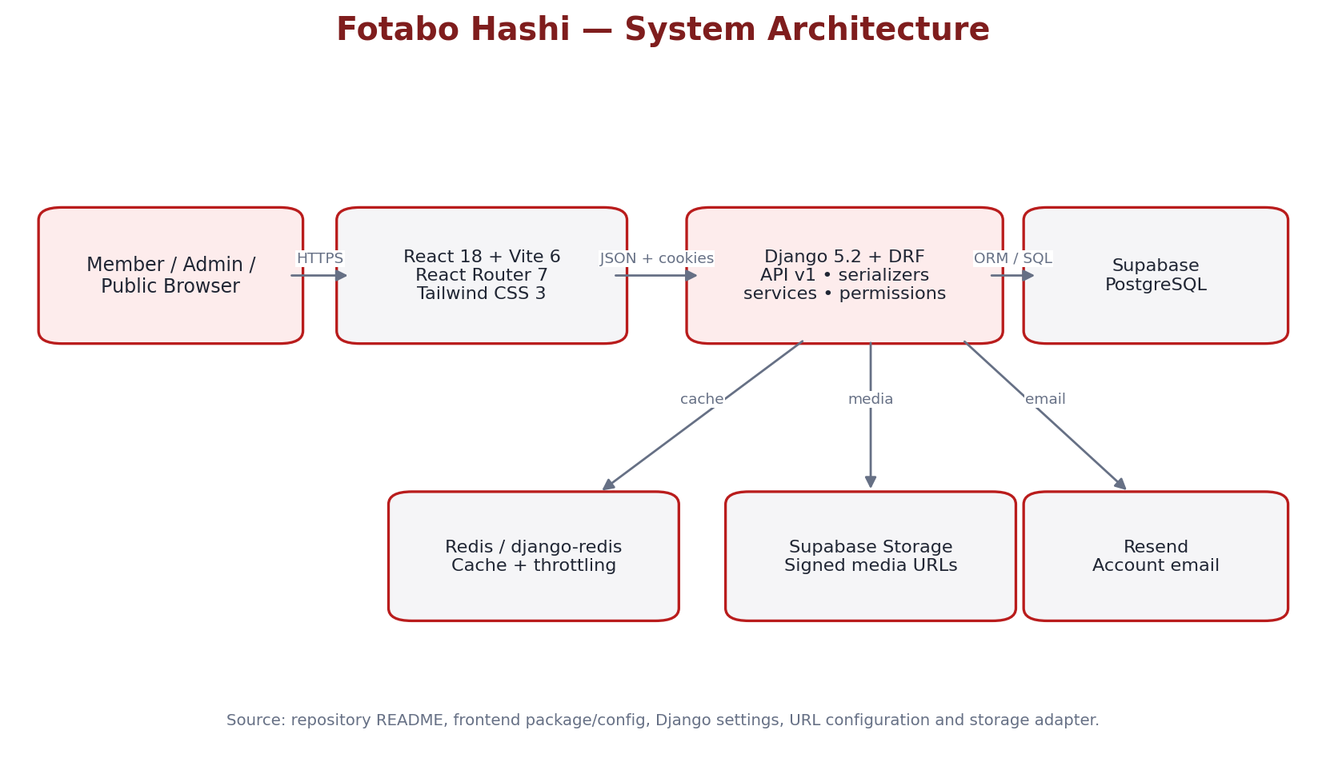
Figure 5.1: Fotabo Hashi complete system architecture
The React SPA is served by Vercel and calls the Django API over HTTPS. Django applies application rules and permissions, reads/writes Supabase PostgreSQL, uses Redis for caching/throttling, accesses Supabase Storage for active-member media and sends account email through Resend. Production Render configuration provisions the API and Redis in Oregon; the README describes Supabase PostgreSQL in US-West (us-west-2).

5.1.1 Admin Control and Monitoring Architecture
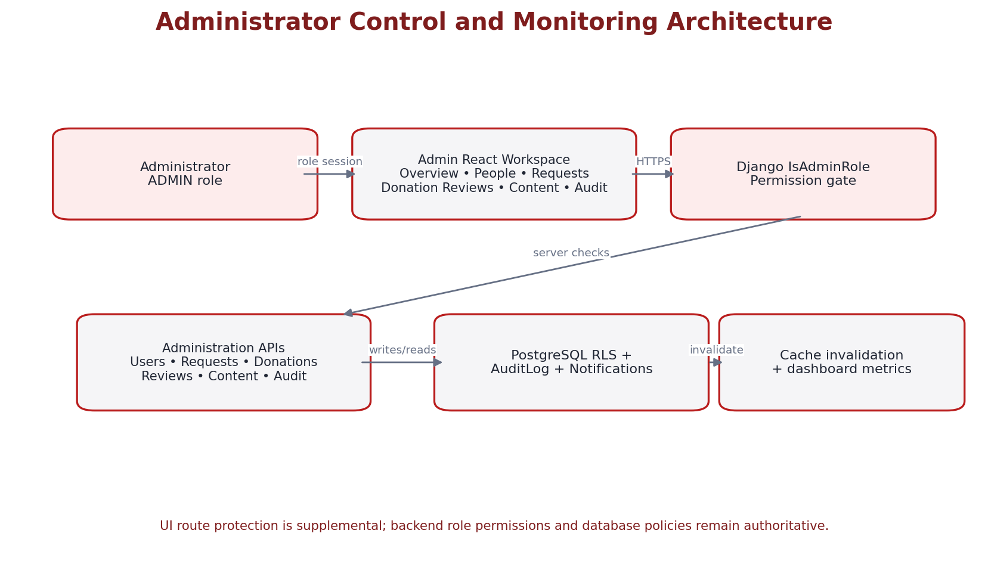
Figure 5.1.1: Administrator control and monitoring architecture
Admin React routes are guarded by the frontend role check, while every admin API uses IsAdminRole. Admin data operations interact with audit logging, notifications, RLS-aware database access and cache invalidation. The admin overview is a monitoring view, not the underlying source of truth.

5.2 System Modeling

Use Case Diagram
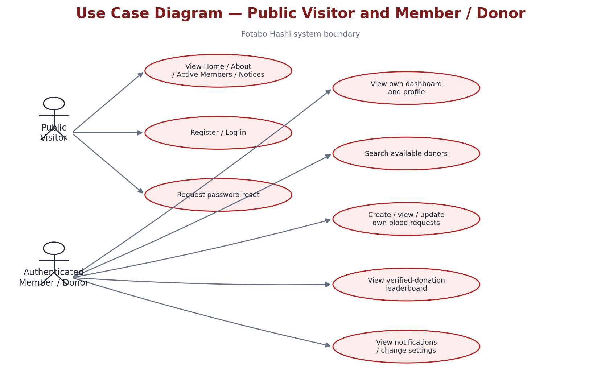
Figure 5.2: Public visitor and authenticated member / donor use cases

Admin Control Use Case Diagram
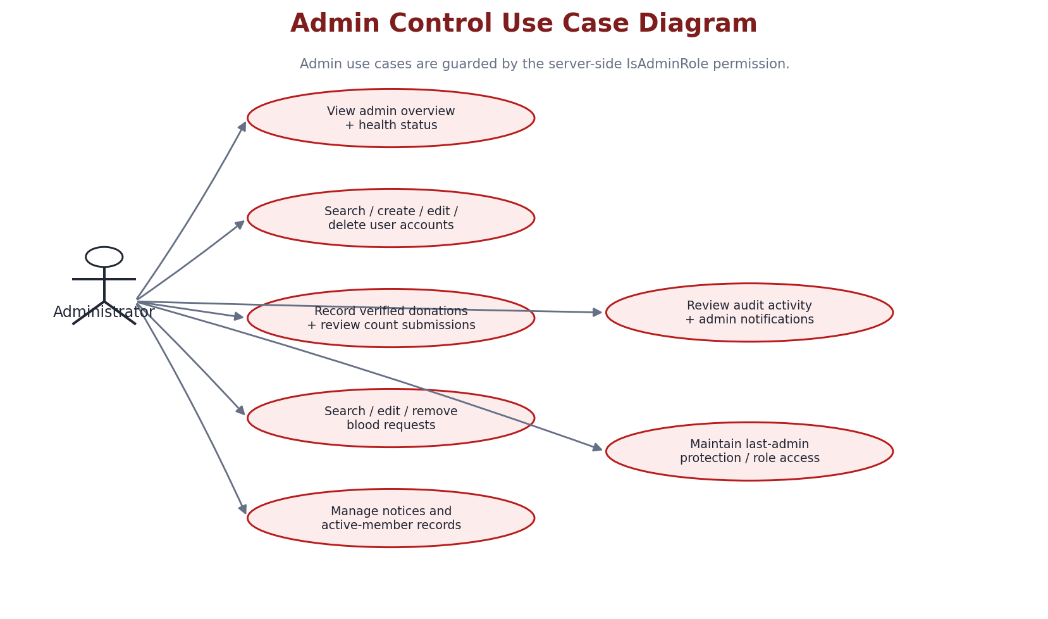
Figure 5.2.1: Admin control use cases

Activity Diagrams

Scenario-1: User Registration / Login / Role Routing
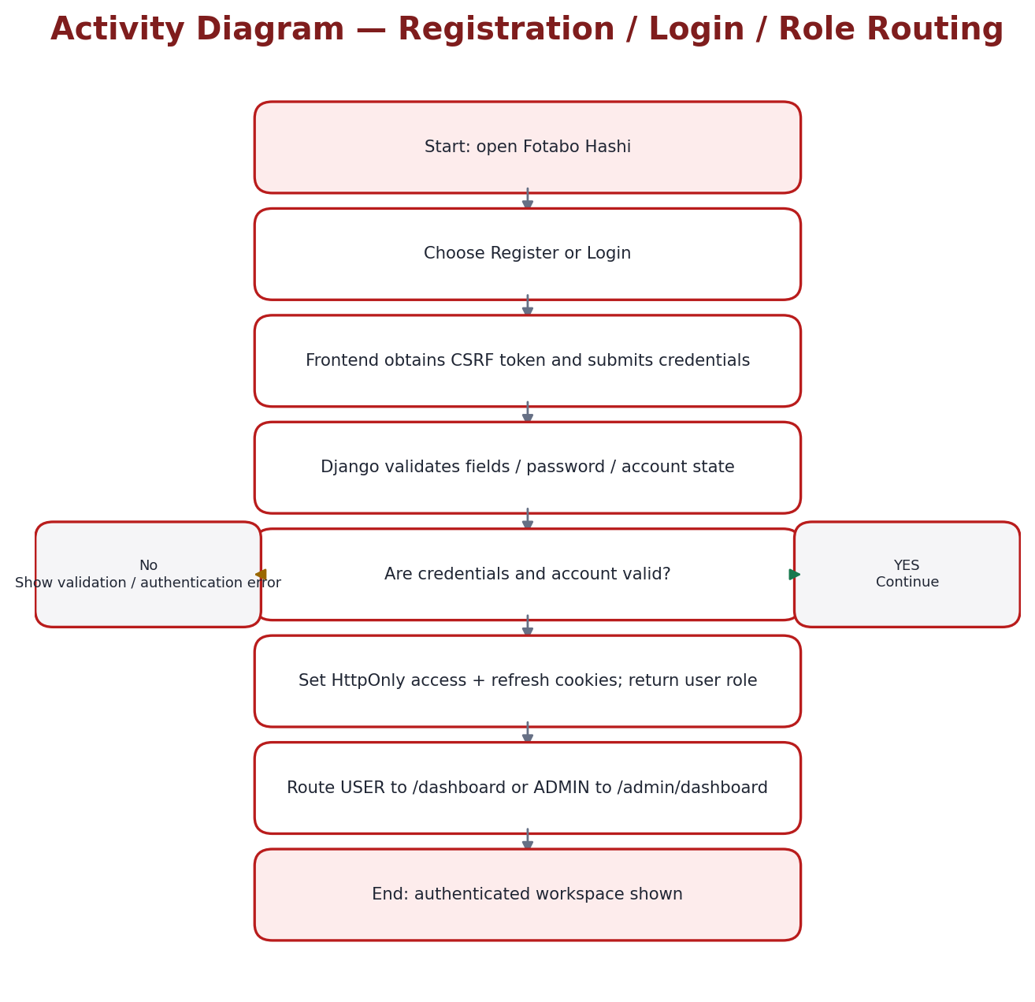
Figure 5.2.2: Registration, login and role-based routing activity

Scenario-2: Donor Search
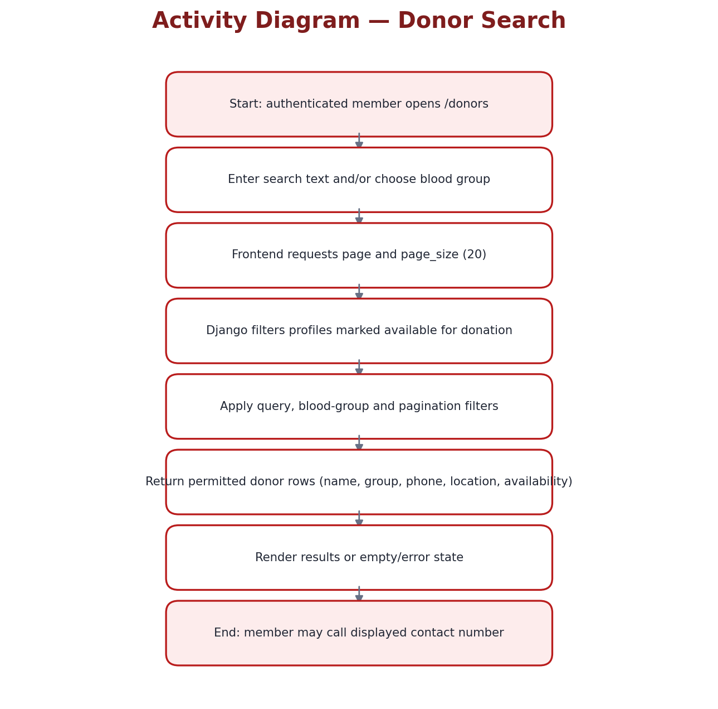
Figure 5.2.3: Available-donor search activity

Scenario-3: Blood Request Creation and Lifecycle
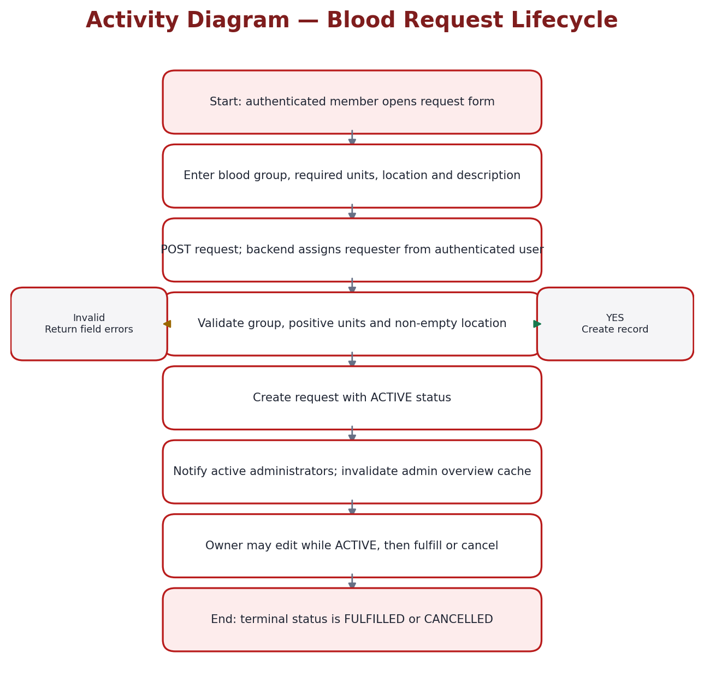
Figure 5.2.4: Blood-request lifecycle activity

Scenario-4: Member Donation Count Review
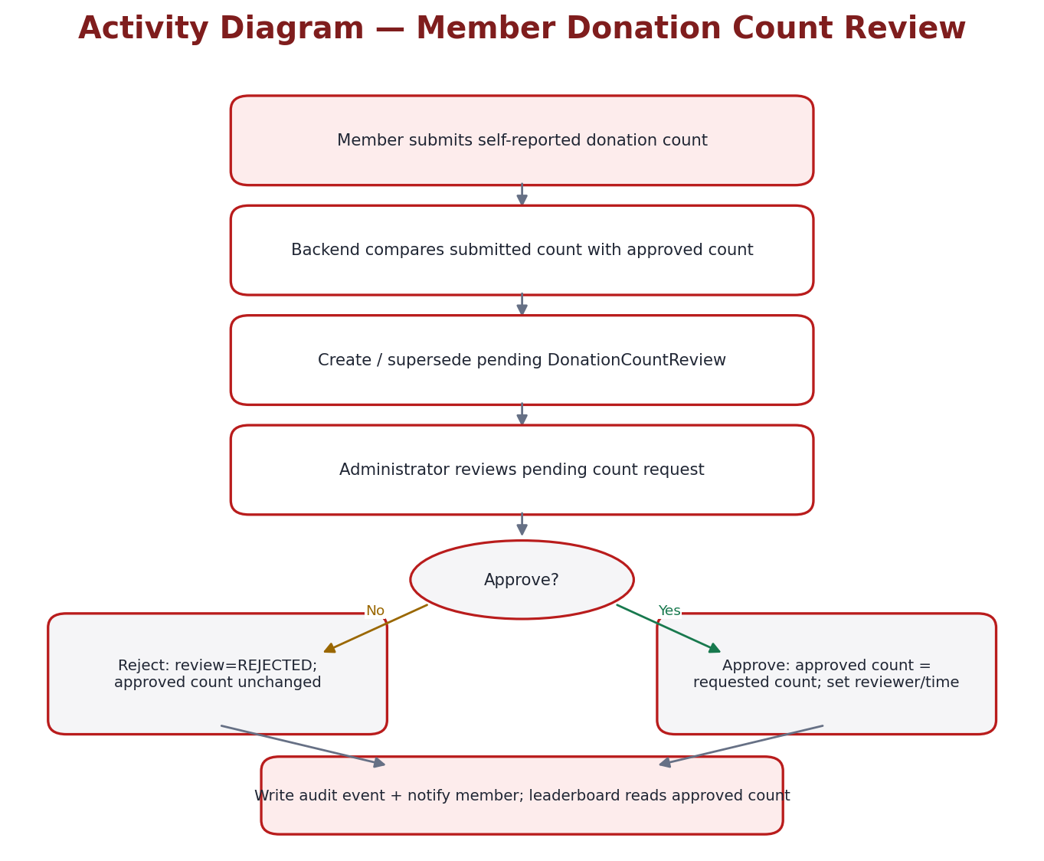
Figure 5.2.5: Member-submitted donation count review with approve/reject branches

Scenario-5: Administrator Records Verified Donation
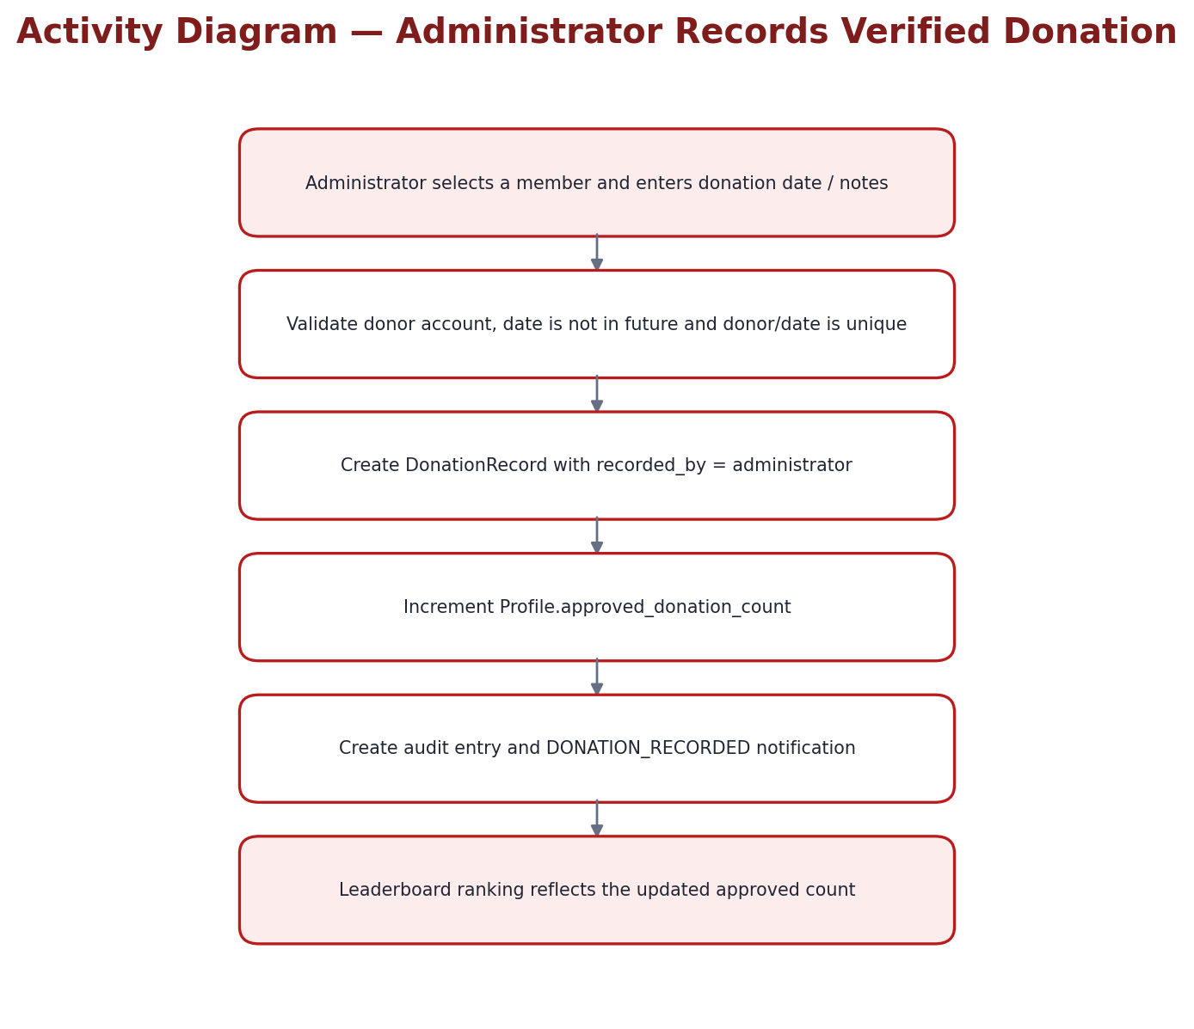
Figure 5.2.6: Verified donation recording and leaderboard update

Scenario-6: Notice and Notification Workflow
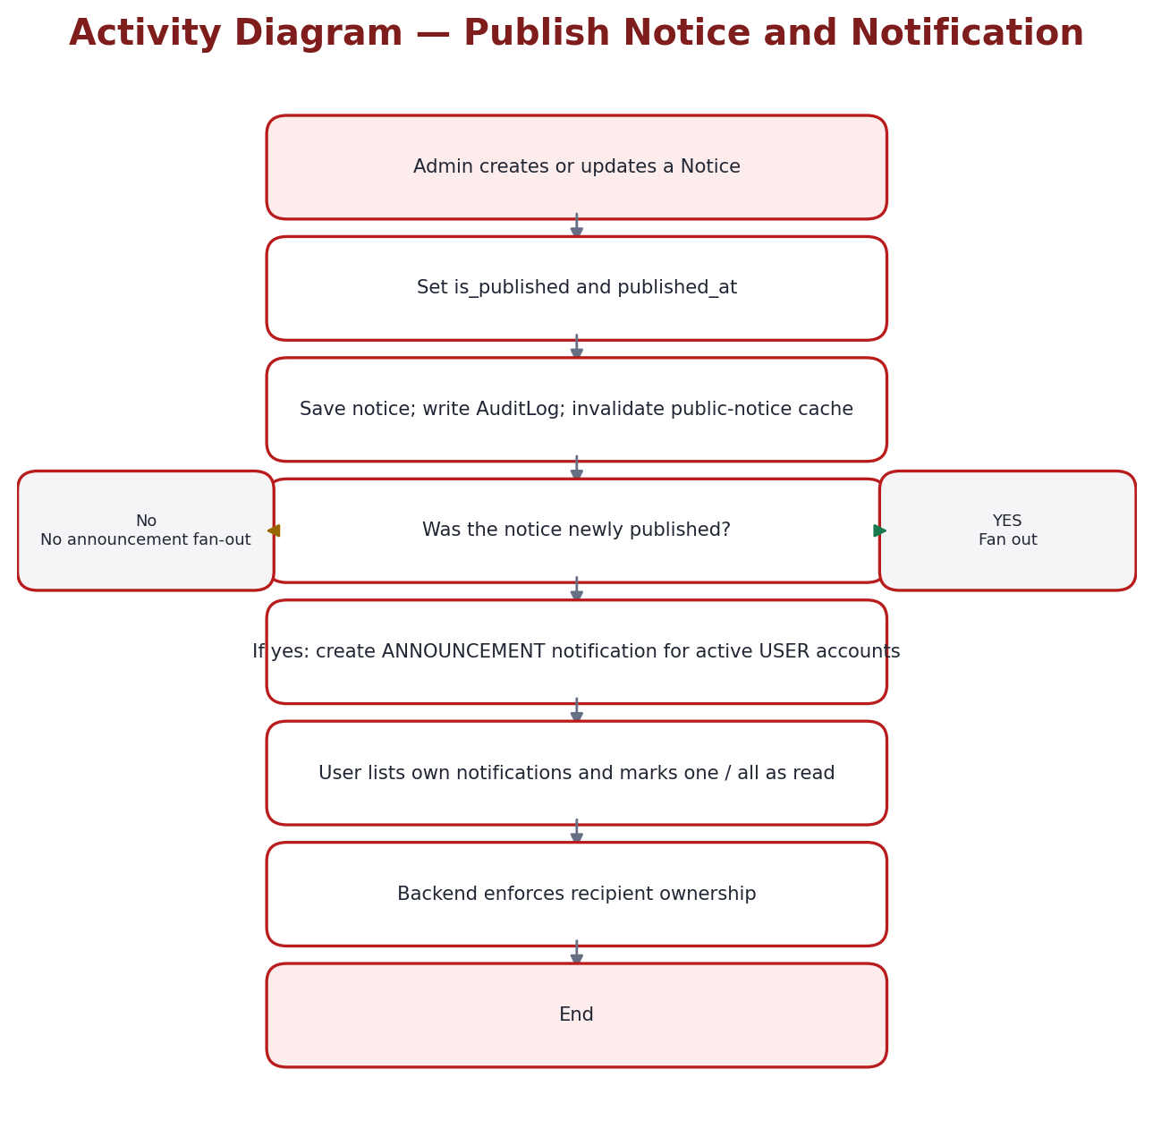
Figure 5.2.7: Publication and recipient notification workflow

Sequence Diagram
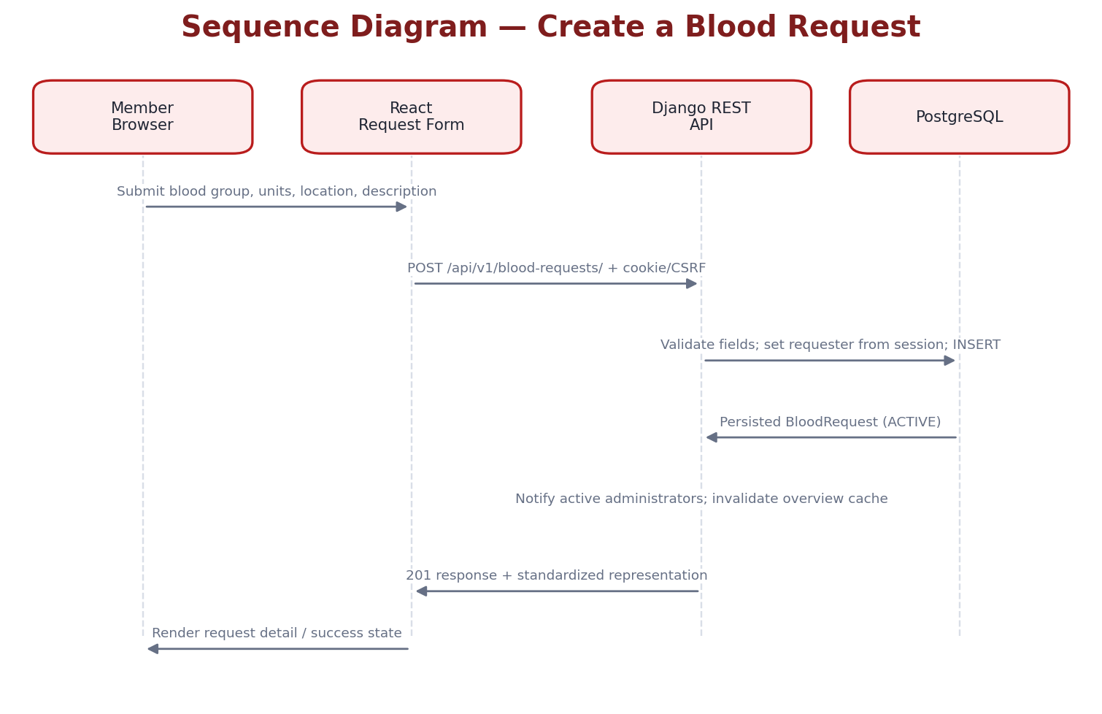
Figure 5.2.8: Blood-request create sequence across browser, frontend, API and database

5.3 Database Design
The ERD below represents the Django model relationships found in source. OrganizationInformation is a public content record; Notice and FoundingMember are separate content entities. FoundingMember.image is a Django file field routed through the configured storage backend. No separate Donor database table exists: donor discovery queries Profile rows where is_available_for_donation=True.

Entity Relationship Diagram (ERD)
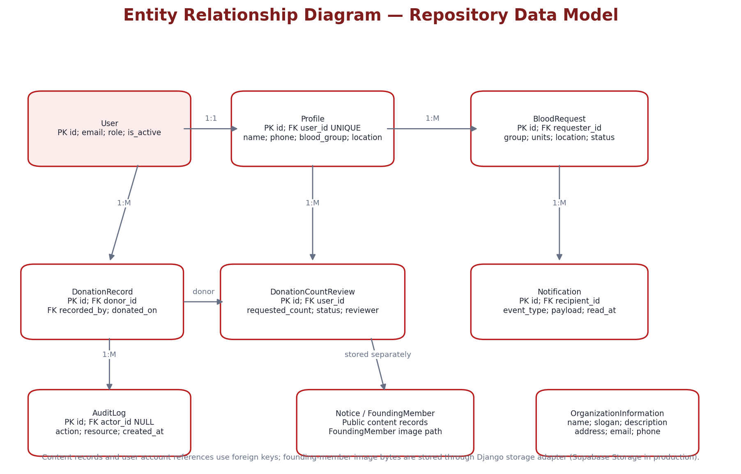
Figure 5.3: Repository data model and principal foreign-key relationships

Data Dictionary

User Table
Field | Data Type | Constraints | Description
id | BIGINT | PK | Unique account identifier.
email | EMAIL | UNIQUE, indexed | Login identifier.
password | HASH | Django managed | Password hash; never returned to clients.
role | VARCHAR(20) | USER / ADMIN; default USER | Authorization role.
is_active | BOOLEAN | Default True | Whether account may authenticate.
is_staff | BOOLEAN | Default False | Django staff flag.
last_login | DATETIME | Nullable, inherited | Last successful login, Django field.
created_at | DATETIME | auto_now_add | Account creation timestamp.
updated_at | DATETIME | auto_now | Last account update.

Profile Table
Field | Data Type | Constraints | Description
id | BIGINT | PK | Profile identifier.
user_id | FK User | OneToOne, CASCADE | One profile per user.
name | VARCHAR(150) | Not blank at validation | Member display name.
phone | VARCHAR(30) | Blank allowed | Contact phone; exposed to authenticated donor search.
blood_group | VARCHAR(3) | Eight-group choice, blank allowed | A+, A-, B+, B-, AB+, AB-, O+, O-.
location | VARCHAR(255) | Blank allowed | Member location used in donor search.
is_available_for_donation | BOOLEAN | Default False, indexed | Directory inclusion switch.
self_reported_donation_count | POSITIVE INT | Default 0 | Member-declared count; not leaderboard-authoritative.
approved_donation_count | POSITIVE INT | Default 0 | Administrator-approved count used for leaderboard.
created_at | DATETIME | auto_now_add | Profile creation time.
updated_at | DATETIME | auto_now | Profile update time.
profile_image | N/A | Not implemented | Migrations removed image field; serializer explicitly rejects profile_image upload.

BloodRequest Table
Field | Data Type | Constraints | Description
id | BIGINT | PK | Unique request identifier.
requester_id | FK User | CASCADE | User who created the request.
blood_group | VARCHAR(3) | Required choice | Requested blood group.
required_units | POSITIVE INT | Required > 0 | Number of units requested.
location | VARCHAR(255) | Required non-empty | Area/hospital location supplied in one field.
description | TEXT | Blank allowed | Additional free-text context.
status | VARCHAR(20) | ACTIVE / FULFILLED / CANCELLED; default ACTIVE | Lifecycle state.
created_at | DATETIME | auto_now_add | Creation time.
updated_at | DATETIME | auto_now | Last update time.
needed_by | N/A | Not implemented | No needed-by datetime field in current model.

DonationRecord Table
Field | Data Type | Constraints | Description
id | BIGINT | PK | Verified donation event.
donor_id | FK User | CASCADE | Member whose donation is recorded.
recorded_by_id | FK User | SET_NULL; nullable | Administrator who entered record.
donated_on | DATE | Default localdate; unique donor/date | Date of verified donation; future date rejected.
notes | VARCHAR(500) | Blank allowed | Administrative notes.
created_at | DATETIME | auto_now_add | Record creation time.

DonationCountReview Table
Field | Data Type | Constraints | Description
id | BIGINT | PK | Member count-change review identifier.
user_id | FK User | CASCADE | Member submitting count change.
previous_count | POSITIVE INT | Required | Approved count when request was made.
requested_count | POSITIVE INT | Required | Count submitted by member.
status | VARCHAR(12) | PENDING / APPROVED / REJECTED / SUPERSEDED | Review state.
reviewed_by_id | FK User | SET_NULL; nullable | Administrator reviewing request.
created_at | DATETIME | auto_now_add, indexed | Submission time.
reviewed_at | DATETIME | Nullable | Review time.
constraint | UNIQUE(user) | Conditional where status=PENDING | At most one pending review per member.

Notification Table
Field | Data Type | Constraints | Description
id | BIGINT | PK | Notification identifier.
recipient_id | FK User | CASCADE; indexed with read_at/created_at | Only this account may read/mark it read.
event_type | VARCHAR(40) | NotificationEvent choices | NEW_ACCOUNT, NEW_BLOOD_REQUEST, REQUEST_UPDATED, ACCOUNT_UPDATED, ANNOUNCEMENT, DONATION_RECORDED, DONATION_COUNT_REVIEW, DONATION_COUNT_REVIEWED.
payload | JSON | Default {} | Structured event details.
action_url | VARCHAR(500) | Blank allowed | Frontend navigation target.
read_at | DATETIME | Nullable | Read timestamp; null means unread.
created_at | DATETIME | auto_now_add, indexed | Creation timestamp.

AuditLog Table
Field | Data Type | Constraints | Description
id | BIGINT | PK | Audit event identifier.
actor_id | FK User | SET_NULL; nullable | User/admin who performed action.
action | VARCHAR(20) | CREATE / UPDATE / DELETE / LOGIN / LOGOUT / SECURITY | Action category.
resource_type | VARCHAR(100) | Required | Affected entity type.
resource_id | VARCHAR(100) | Blank allowed | Affected entity identifier.
description | TEXT | Blank allowed | Human-readable audit note.
ip_address | GenericIPAddress | Nullable | Request origin IP (not exposed in list API).
user_agent | TEXT | Blank allowed | Browser/agent (not exposed in list API).
metadata | JSON | Default {} | Additional context (not exposed in list API).
created_at | DATETIME | auto_now_add; indexed | Audit timestamp.

OrganizationInformation Table
Field | Data Type | Constraints | Description
id | BIGINT | PK | Organization content identifier.
name | VARCHAR(200) | Required | Organization name.
slogan | VARCHAR(255) | Blank allowed | Public slogan.
description | TEXT | Required | Organization description.
address | VARCHAR(255) | Blank allowed | Public address.
email | EMAIL | Blank allowed | Public organization email.
phone | VARCHAR(30) | Blank allowed | Public organization phone.
updated_at | DATETIME | auto_now | Last update.

Notice Table
Field | Data Type | Constraints | Description
id | BIGINT | PK | Notice identifier.
title | VARCHAR(255) | Required | Notice title.
content | TEXT | Required | Notice body.
is_published | BOOLEAN | Default False | Public visibility flag.
published_at | DATETIME | Nullable | Publication timestamp.
created_at | DATETIME | auto_now_add | Creation time.
updated_at | DATETIME | auto_now | Last update.

FoundingMember Table
Field | Data Type | Constraints | Description
id | BIGINT | PK | Active/founding member record.
name | VARCHAR(150) | Required | Member name.
designation | VARCHAR(150) | Blank allowed | Designation.
social_url | URL | Blank allowed in model; admin serializer requires URL | Public social link.
image | ImageField | Nullable; Supabase Storage in production | Image object path; image bytes external to PostgreSQL.
description | TEXT | Blank allowed | Member biography.
display_order | POSITIVE INT | Default 0 | Public ordering.
is_published | BOOLEAN | Default True | Public display toggle.
created_at | DATETIME | auto_now_add | Creation time.
updated_at | DATETIME | auto_now | Last update.

Database Integrity Rules
- A User has one Profile through a OneToOne relation; deleting the User cascades its Profile.
- A BloodRequest is owned by requester; normal members may only update/fulfill/cancel their own request.
- A request can only be updated, fulfilled or cancelled while ACTIVE; client-supplied status is read-only for the member serializer.
- A donor search result is drawn from Profile rows with is_available_for_donation=True.
- A user can have no more than one PENDING DonationCountReview at a time.
- A donor cannot have two DonationRecord rows on the same donated_on date.
- A future donation date is invalid.
- Leaderboard values use approved_donation_count; self_reported_donation_count is not authoritative.
- Notification read operations filter by recipient=current user.
- RLS context is set from authenticated identity and cleared at request end to prevent pooled-connection identity leakage.
- FoundingMember media object paths are generated with UUIDs; profile image upload is not supported.

6. Technical Implementation

6.1 Backend / Data Interaction Documentation

6.1.1 Backend Organization
The backend is a Django project split into domain apps. Shared response/error handling, pagination, throttling, request-ID middleware, database/RLS context, caching, storage, logging and monitoring are kept under shared/infrastructure modules.
backend/
├── api/v1/ # Versioned API routes, OpenAPI and health endpoints
├── apps/
│ ├── accounts/ # Custom email user, registration, JWT cookies, password flows
│ ├── profiles/ # One-to-one member profile and self-reported counts
│ ├── donors/ # Available-profile queryset and filtering
│ ├── blood_requests/ # Request model, filters, services and owner rules
│ ├── leaderboard/ # DonationRecord, DonationCountReview and ranking
│ ├── content/ # OrganizationInformation, Notice, FoundingMember
│ ├── notifications/ # Event notifications and read state
│ ├── administration/ # Admin overview, accounts, donations, content, requests
│ ├── audit/ # AuditLog model and service
│ └── common/ # Errors, pagination, rendering, throttles, middleware
├── config/settings/ # base, development, testing and production settings
├── infrastructure/ # RLS, cache, storage, logging and monitoring
├── tests/ # API, integration, performance and security suites
├── manage.py
└── requirements.txt

6.1.2 RESTful API Endpoints
Base API path: /api/v1/. All endpoint paths below were taken from the repository URL configuration and endpoint map. Authentication column describes endpoint-level permission intent; specific views may additionally apply ownership, status and throttling rules. Standard list responses use the project pagination envelope.
Module | HTTP | Endpoint suffix | Purpose | Access
Health | GET | /health/ | Dependency readiness and service/version checks | Public
Health | GET | /health/live/ | Process liveness check | Public
Health | GET | /health/ready/ | Readiness/dependency probe | Public
OpenAPI | GET | /schema/ | OpenAPI schema | Public / docs config
OpenAPI | GET | /docs/ | Swagger UI | Public / docs config
OpenAPI | GET | /redoc/ | ReDoc | Public / docs config
Auth | POST | /auth/register/ | Create member; returns user and sets cookies | Public + throttle
Auth | POST | /auth/login/ | Email/password sign-in; remember_me optional | Public + throttle + CSRF
Auth | POST | /auth/refresh/ | Rotate refresh/access cookies | Refresh cookie + CSRF
Auth | POST | /auth/logout/ | Blacklist refresh token, clear cookies, audit logout | Public route; CSRF
Auth | GET | /auth/csrf/ | Issue CSRF token | Public
Auth | GET | /auth/me/ | Return current session identity; 204 if anonymous | Optional auth
Auth | POST | /auth/password-reset/ | Send reset link by email | Public + throttle
Auth | POST | /auth/password-reset/confirm/ | Confirm uid/token/new_password | Public + throttle
Auth | POST | /auth/password-change/ | Change current password | Authenticated + throttle
Profile | GET | /profile/me/ | Read own ProfileSerializer fields | Authenticated
Profile | PUT | /profile/me/ | Full update own profile | Authenticated
Profile | PATCH | /profile/me/ | Partial update own profile / donation-count declaration | Authenticated
Donors | GET | /donors/ | Available donors with search/name/group/location filters | Authenticated; IsAuthenticated
Blood Requests | GET | /blood-requests/ | List/search/filter; supports mine=true | Authenticated
Blood Requests | POST | /blood-requests/ | Create ACTIVE request; requester forced to current user | Authenticated + create throttle
Blood Requests | GET | /blood-requests/mine/summary/ | Current member total/active/fulfilled/recent five | Authenticated
Blood Requests | GET | /blood-requests/{id}/ | Request detail with requester_name and is_owner | Authenticated
Blood Requests | PATCH | /blood-requests/{id}/ | Update own ACTIVE request; status read-only | Owner only
Blood Requests | POST | /blood-requests/{id}/fulfill/ | Mark own ACTIVE request FULFILLED | Owner only + action throttle
Blood Requests | POST | /blood-requests/{id}/cancel/ | Mark own ACTIVE request CANCELLED | Owner only + action throttle
Leaderboard | GET | /leaderboard/ | Top 100 active USERs ranked by approved count | Authenticated
Public Content | GET | /content/organization/ | Organization public fields | AllowAny
Public Content | GET | /content/notices/ | Published notices only | AllowAny
Public Content | GET | /content/active-members/ | Published active/founding-member records | AllowAny
Notifications | GET | /notifications/ | List only current recipient notifications | Authenticated
Notifications | POST | /notifications/{id}/read/ | Mark own notification read | Recipient only
Notifications | POST | /notifications/read-all/ | Mark all own notifications read | Authenticated
Admin | GET | /admin/overview/ | Platform overview metrics | ADMIN
Admin Users | GET | /admin/users/ | Search/filter user accounts | ADMIN
Admin Users | POST | /admin/users/ | Create account and send password setup/reset email | ADMIN
Admin Users | GET | /admin/users/{id}/ | Read user detail | ADMIN
Admin Users | PATCH | /admin/users/{id}/ | Update account/profile and role/status | ADMIN; last-admin safeguards
Admin Users | DELETE | /admin/users/{id}/ | Delete account | ADMIN; self/last-admin guards
Admin Donations | GET | /admin/users/{user_pk}/donations/ | List verified donation records for one member | ADMIN
Admin Donations | POST | /admin/users/{user_pk}/donations/ | Record verified donation and increment approved count | ADMIN; unique donor/date
Admin Donations | DELETE | /admin/users/{user_pk}/donations/{id}/ | Remove verified donation record and decrement count | ADMIN
Admin Reviews | GET | /admin/donation-reviews/ | List pending member count reviews | ADMIN
Admin Reviews | POST | /admin/donation-reviews/{id}/approve/ | Approve member-submitted count | ADMIN
Admin Reviews | POST | /admin/donation-reviews/{id}/reject/ | Reject member-submitted count | ADMIN
Admin Requests | GET | /admin/blood-requests/ | Admin list/filter requests | ADMIN
Admin Requests | POST | /admin/blood-requests/ | Admin create a request for a selected requester | ADMIN
Admin Requests | GET | /admin/blood-requests/{id}/ | Admin request detail | ADMIN
Admin Requests | PATCH | /admin/blood-requests/{id}/ | Admin update request/status | ADMIN
Admin Requests | DELETE | /admin/blood-requests/{id}/ | Admin delete request | ADMIN
Admin Content | GET/POST | /admin/public-content/members/ | List/create active-member records | ADMIN
Admin Content | GET/PATCH/DELETE | /admin/public-content/members/{id}/ | Read/update/delete member record | ADMIN
Admin Content | GET/POST | /admin/public-content/notices/ | List/create notices | ADMIN
Admin Content | GET/PATCH/DELETE | /admin/public-content/notices/{id}/ | Read/update/delete notices | ADMIN
Admin Audit | GET | /admin/audit/ | Read audit records; action/resource_type/recent filters | ADMIN

6.1.3 API Request / Response Conventions
- Paginated list response: {success:true,data:{count,next,previous,results:[...]}}; default page size 20, page_size query option up to 100.
- Success helper wraps data as {success:true,data:...}; some endpoints return compact direct fields/arrays; follow actual serializer/view response for each endpoint.
- Error response: {success:false,error:{code,message,details,request_id}}; X-Request-ID is also returned in response header.
- Frontend API client sends credentials: include, warms/reads CSRF token and sets X-CSRFToken on unsafe HTTP methods.
- API client retries a 401 session refresh once (except login/refresh); mutation requests clear its API cache after success.
- Global DRF default throttles are anonymous 100/hour and user 1000/hour; specialized rates include login 10/min, refresh 30/min, registration 5/hour, reset 5/hour, password-change 5/hour, request-create 30/hour and request-actions 60/hour.

6.1.4 Authentication and Session Rules
Item | Implemented behavior
User identity | Custom User model uses unique email as USERNAME_FIELD; no username field.
Roles | USER and ADMIN; ADMIN defaults staff flag when created by admin serializer.
Cookie names | fh_access and fh_refresh; HttpOnly=True; production Secure=True and SameSite=None.
Token lifetime | Access token 15 minutes; refresh token 7 days; rotate refresh tokens and blacklist after rotation.
Remember me | Login serializer accepts remember_me; cookie max-age is set when remembered; session cookies otherwise.
CSRF | Cookie-authenticated unsafe requests enforce Django CSRF validation; frontend fetches CSRF endpoint and sends X-CSRFToken.
Refresh | POST /auth/refresh/ reads refresh cookie and reissues cookies.
Logout | Refresh token blacklisting is attempted; cookies are cleared; authenticated logout creates audit entry.
Password reset | UID + token + new password confirmation; email delivered through Resend in production.
Bearer fallback | CookieOrBearerJWTAuthentication accepts Authorization Bearer JWT while migration compatibility is required.

6.1.5 Donor Search Implementation
There is no dedicated Donor model in the current repository. DonorListView is backed by Profile rows filtered through is_available_for_donation=True. Supported filter fields are search (name/location/blood group combined), blood_group, location (case-insensitive contains) and name (case-insensitive contains). Results are ordered by name then id and paginated. DonorSerializer exposes id, name, blood_group, phone, location and availability. The endpoint requires authentication.
The frontend currently sends page, page_size, search and blood_group. Although backend location/name filters exist, they are not independent controls on the current donor-search page. The page presents a horizontally scrollable table and a telephone link when a phone number is present.

6.1.6 Blood Request Lifecycle
Transition / operation | Rule
Create | Authenticated; requester is assigned from request.user; required_units must be >0; location must not be blank; status from client is discarded; initial status ACTIVE.
Read list/detail | Authenticated. List supports search, group, status, location and mine=true; detail returns requester_name and is_owner.
Update | Only requester/owner; service refuses updates unless status is ACTIVE; user serializer marks status read-only.
Fulfill | POST /{id}/fulfill/; only owner, only ACTIVE; result FULFILLED.
Cancel | POST /{id}/cancel/; only owner, only ACTIVE; result CANCELLED.
Notifications | Create notifies administrators; owner status updates/actions notify requester.
Dashboard summary | Returns total, active, fulfilled and latest five own requests; there is no separate cancelled count field.

The request schema contains no hospital field, recipient name, phone/contact preference or needed_by date/time. The current UI uses one location field and optional description. Request detail explicitly states the application does not provide an in-app contact request or show patient/requester contact information.

6.1.7 Donation Verification and Leaderboard
Two separate values are maintained on Profile. self_reported_donation_count is member-entered and can trigger a DonationCountReview. approved_donation_count is administrator-approved and is the source used by the leaderboard. DonationRecord stores individual admin-recorded events (donor, recorder, donated_on, notes, created_at), prohibits a duplicate donor/date and disallows future dates. Admin record creation increments approved_donation_count and generates an audit event and DONATION_RECORDED notification. The separate count-review approval sets approved_donation_count to the requested count; rejection leaves it unchanged. The leaderboard ranks active USER accounts with approved_donation_count >0 using DenseRank and returns up to 100 results.

6.1.8 Notification Rules
Event type | Trigger / use
NEW_ACCOUNT | Admin-created account notice to the new user; admin notification on new account creation.
NEW_BLOOD_REQUEST | New user or admin blood request; fan-out to active administrators.
REQUEST_UPDATED | Request status changes/actions; sent to requester.
ACCOUNT_UPDATED | Admin account/profile changes; sent to affected account.
ANNOUNCEMENT | Notice becomes published; fan-out to active USER accounts.
DONATION_RECORDED | Administrator records verified DonationRecord; sent to donor.
DONATION_COUNT_REVIEW | User-submitted count change creates review; administrators notified.
DONATION_COUNT_REVIEWED | Admin approves/rejects review; member notified.

Notifications are stored in PostgreSQL and delivered through in-app API retrieval. The repository does not implement WebSocket delivery; frontend header NotificationCenter uses the in-app endpoint behavior. Read state is represented by read_at; API serializes this as is_read.

6.1.9 Admin Control and Monitoring
- Admin overview metrics: total users, active users, donors available for donation, total/active blood requests, total audit events, users created in last seven days and requests created in last seven days. Overview is cached for about 60 seconds.
- Admin user queries support role, active, search, name, email, phone, blood_group, donation_count_change and sort=self_reported_count.
- Creating a user creates an account/profile with no password and sends password setup/reset email. Admin user output includes donor availability, approved and self-reported donation count and review metadata.
- Admin protects current account deletion and last active administrator deletion/demotion/deactivation.
- Admin request management may create requests for a selected requester and may update/delete records. Mutations are audited.
- Admin public content supports Notices and FoundingMember records. Publishing a notice sends ANNOUNCEMENT notifications; public content caches are invalidated after changes.
- Audit listing exposes actor email, action, resource_type, resource_id, description and created_at; IP address, user agent and metadata are deliberately omitted from this API serializer.

6.1.10 Media Handling Rules
- Production STORAGE_BACKEND=supabase; local development uses LocalMediaStorage rooted at MEDIA_ROOT.
- SupabaseStorage uses server-side SUPABASE_SERVICE_ROLE_KEY and a configured bucket (default fotabo-hashi-media). It uploads, downloads, deletes and creates signed URLs with configurable TTL (default 3600 seconds).
- Current model-backed public media are FoundingMember.image objects with generated UUID object paths under founding-members/.
- Founding-member photo uploads accept JPEG, PNG or WebP, maximum configured size (default 5 MB) and maximum 5000px width/height.
- Member profile image upload is explicitly disabled: profile_image field was removed in migrations and ProfileSerializer rejects profile_image input.
- Hero media (slides/video) are frontend static assets, not admin-managed database uploads.
- Supabase service-role key and database credentials must never be exposed as VITE_ frontend variables.

6.1.11 Database RLS, Cache, Rate Limits and Monitoring
- PostgreSQL RLS migrations and policies cover accounts_user, profiles_profile, blood_requests_bloodrequest, leaderboard_donationrecord, leaderboard_donationcountreview, content_organizationinformation, content_notice, content_foundingmember and audit_auditlog.
- CookieOrBearerJWTAuthentication derives user id and role and sets PostgreSQL connection-local RLS context (user id, admin flag, authenticated flag and login-email scope). Temporary trusted server-side admin context is used for narrowly scoped operations. Middleware clears request context before persistent connection reuse.
- Redis/django-redis is the production cache and throttling backend; local development may use in-memory LocMemCache if DJANGO_USE_REDIS_CACHE is false.
- Health endpoints report service readiness and dependency checks; liveness is a simpler process check.
- RequestIDMiddleware echoes X-Request-ID and includes the ID in structured response errors/logging; Sentry can capture exceptions when DSN is configured.

6.2 Relationship & Access Rules
Role / state | Allowed operations | Restricted actions / notes
Unauthenticated visitor | View Home content sections; read organization info/notices/active-member data; register/login/reset password. | Cannot call donor, request, profile, leaderboard or private notification APIs.
USER member | Read/update own profile; set availability; search available donors; create/list/read requests; update/fulfill/cancel own active requests; view leaderboard; read/mark own notifications; submit self-reported donation count. | Cannot administer another account, access audit data, write verified donation records, approve reviews or alter another member’s request/profile. Donor phone/location are currently returned to authenticated search clients.
ADMIN | All administrative endpoints: overview, account search/create/update/delete, donation recording/reviews, request management, public notices/active members, audit listing; also standard member API according to routes. | Admin actions remain subject to last-active-admin safeguards and audit rules; ordinary client-side hiding is not authorization.
Disabled account | is_active false; authentication denied by Django/JWT account rules. | Cannot access protected member/admin endpoints.
Public content | Organization info, published notices, published active members are AllowAny. | Unpublished notices/members are not in public lists; admin content APIs require ADMIN.
Notification recipient | Read and update own notification only. | Cannot mark another user’s notification read.

6.3 Frontend Organization
The frontend is organized into route-level features, shared layout/UI components, authentication and language contexts, a centralized API client, endpoint configuration, locale dictionaries and design tokens. React.lazy and Suspense are used for page chunks; route layouts separate public, member and admin experiences.
frontend/
├── public/ # Logo, developer portrait, hero media and screenshots
├── src/
│ ├── app/ # Application router/providers
│ ├── components/
│ │ ├── errors/ # Error boundary and global error notice
│ │ ├── layout/ # PublicHeader/Footer, DashboardLayout, AdminLayout, nav
│ │ ├── seo/ # SeoManager
│ │ └── ui/ # Avatar, Badge, Button, Card, Input, Select, Textarea,
│ │ # Skeletons, EmptyState, Pagination, FilterMenu, etc.
│ ├── contexts/ # AuthContext and LanguageContext
│ ├── features/
│ │ ├── public/ # Home page + Hero/About/ActiveMembers/Notice sections
│ │ ├── authentication/ # Login, Register, ForgotPassword, ResetPassword
│ │ ├── dashboard/ # Member dashboard
│ │ ├── donors/ # DonorSearchPage
│ │ ├── blood-requests/ # List, Create, Detail
│ │ ├── leaderboard/ # Verified donation ranking
│ │ ├── profile/ # Member profile
│ │ ├── settings/ # Language/notification indicator/password
│ │ └── administration/ # Admin overview/users/reviews/requests/content/audit
│ ├── i18n/locales/ # English and Bangla JSON dictionaries
│ ├── services/ # apiClient, csrfService, endpointConfig
│ ├── styles/ # design-tokens.css and globals.css
│ ├── utils/ # constants, dates, formatters
│ ├── index.css
│ └── main.jsx
├── package.json
└── vercel.json

6.3.1 Public Frontend Organization
- PublicLayout composes PublicHeader, content outlet and PublicFooter.
- HomePage composes HeroSection, AboutSection, ActiveMembers and NoticeSection; public data is fetched via publicContentService.
- PublicHeader includes Home brand link, anchor links to About/Active Members/Notices, mobile menu and language toggle; Login is the public authentication action.
- AboutSection displays organization narrative plus Mission, Vision and Values cards. ActiveMembers displays published member cards; NoticeSection displays title/content/published date.
- The current public route list does not contain standalone About, Services, Founders or Notices pages. Services and Founders are not independent route components in the current route tree.

6.3.2 Member Frontend Organization
- DashboardLayout provides AppHeader, desktop Sidebar, member content outlet, PublicFooter and fixed MobileNavigation.
- AppHeader contains brand, language toggle, NotificationCenter and ProfileMenu.
- Desktop Sidebar has Dashboard, Donors, Requests, Leaderboard, Profile and Settings.
- Current MobileNavigation has four items: Dashboard, Donors, Requests and Leaderboard. Profile and Settings are not in the fixed bottom bar, which is a documented user-requirement gap.
- Dashboard page uses profile + own request summary API calls and quick actions. The identity card uses initials avatar; no member avatar upload is implemented.

6.3.3 Frontend Design and Style
Design item | Current source values / behavior
Canvas | --bg: #f5f5f7; surface: #ffffff; highlight: #ffffff.
Brand colors | --red: #b91c1c; --red-deep: #7f1d1d; --red-soft: #fdecec.
Text | --ink: #0f172a; --muted: #475569; --line: #e2e8f0.
Shapes | Card radius 16px; control radius 12px.
Shadow | Very subtle raised shadow 0 1px 3px rgba(15,23,42,.06); inset shadow none.
Typography | DM Sans for body; Manrope for headings.
Responsive base | body min-width 320px; mobile page-shell gutter 1.5rem up to 640px.
Accessibility styling | 3px visible :focus-visible outline; reduced-motion media query disables transitions/animations.
Public footer | Dark burgundy #361414; responsive four-column desktop grid and stacked small-screen layout.
Neumorphism | Soft cards/buttons with visible border and subtle raised shadow; not heavy inset effect.

6.3.4 Current UI / User-Target Gap Register
ID | Owner target / requested design | Current repository implementation | Status / action
UI-GAP-01 | Mobile bottom navigation should include main functions and Settings. | Member bottom nav is Dashboard, Donors, Requests, Leaderboard; Settings/Profile available elsewhere. | Gap: add Settings to bottom bar or provide an explicit mobile More/Settings destination.
UI-GAP-02 | Dashboard first identity block: circular profile image, name, blood group, donation count. | Dashboard uses initials Avatar, name, role, email, phone, location and blood group; approved donation count is not shown there. | Gap: show approved_donation_count in the dashboard identity/summary area.
UI-GAP-03 | User avatar/profile image. | Profile image upload field removed; serializer rejects profile_image; avatar component uses initials. | Current behavior: no user profile photo upload; decide whether to add field/storage workflow.
UI-GAP-04 | Public header links Home, About, Services, Founders, Login. | Header anchors About, Active Members, Notices; Login; Home via logo. | Gap: Services/Founders nav destinations/sections need a product decision.
UI-GAP-05 | Distinct public About, Services, Founders content/pages. | Home includes About, ActiveMembers and Notices sections; no separate route pages; no distinct Services route. | Gap: add standalone pages or update scope/links.
UI-GAP-06 | Footer like owner-supplied screenshot with bottom credit and technology strip. | Current footer has brand/contact, Company, Quick Links, Developer portrait/socials and copyright line; no technology strip or exact “Made with” credit strip in the current JSX. | Partial: layout elements largely exist; reconcile bottom strip and screenshot styling.
UI-GAP-07 | Mobile-first 98% phone usage. | CSS supports 320px and responsive layouts; some data tables intentionally have horizontal scrolling (donor list, admin tables). | Partially verified: manual testing on actual phones and all routes required.
UI-GAP-08 | Blood requests may contain needed-by/hospital/contact context in future spec. | Current BloodRequest fields are blood_group, required_units, location, description and status only. | Not implemented: do not assume fields; schema and UX extension needs approval.
UI-GAP-09 | Separate founder and notices pages. | Public homepage sections + admin content routes; no detail/public pages separate. | Scope decision: retain homepage sections or build new routes.
UI-GAP-10 | Donation-history / certificate features. | DonationRecord is admin-verified event data; no certificate generation or user donation history screen. | Not implemented; do not infer certificates/history management.

6.4 Administration Frontend Organization
AdminLayout provides an independent header, admin navigation and content outlet. Desktop uses a sidebar; mobile uses a horizontally scrollable six-item bottom navigation. The current admin route set and primary pages are:
Page / route | Current responsibilities
/admin/dashboard | Admin overview metrics, health status, recent audit activity and shortcuts.
/admin/users | Search/filter/create/update/delete users; role/status; profile data; verified donation records for selected USERs.
/admin/donation-reviews | List pending self-reported donation-count changes; approve/reject.
/admin/requests | Search/filter/manage blood requests; create/update/delete as admin.
/admin/public-content | Manage notices and active-member records including image upload.
/admin/audit | Paginated read-only audit activity.

Admin UI visibility is not relied upon for security. All administration routes are protected with RequireAdmin and every administration API checks IsAdminRole. The backend also protects last-active-admin continuity.

7. Quality Assurance & Testing
The repository contains backend tests across app-level API/model tests and shared security, RLS, performance, storage, monitoring and contract suites. The GitHub Actions workflow defines backend lint/format/dependency audit/Django check/pytest/OpenAPI validation and frontend dependency audit/lint/build jobs. The test statuses below indicate source coverage or recommended verification, not the latest CI result.

7.1 Test Case Scenarios
Test ID | Test description | Input / condition | Expected result | Evidence status
TC-01 | User registration | Valid email, name, phone, blood group and valid password | 201; account/profile created; auth cookies set | Repository test exists
TC-02 | Duplicate email registration | Email already exists case-insensitively | 400 validation response; no duplicate account | Repository test exists
TC-03 | Invalid login | Wrong password / inactive account | 401; generic invalid email or password | Repository test exists
TC-04 | Remember-me cookie handling | remember_me false/true | Cookie max-age follows selected remember option | Verify
TC-05 | CSRF for cookie auth | Unsafe request without valid CSRF | 403/CSRF failure | Repository test exists
TC-06 | Refresh token | Valid refresh cookie | New access cookie / rotated refresh as configured | Repository test exists
TC-07 | Logout and blacklist | Logout with refresh cookie | Cookies cleared; refresh blacklisted; audit row if actor identified | Repository test exists
TC-08 | Password reset request | Known account + Resend success | Reset email sent; generic flow according to API outcome | Repository test exists
TC-09 | Password reset confirmation | Valid UID/token/new password | Password changed; auth cookies cleared | Repository test exists
TC-10 | Password change | Correct current password + valid new password | Password changed; cookies cleared; re-authentication required | Repository test exists
TC-11 | Profile auto creation | Create new User | One Profile created by signal | Repository test exists
TC-12 | Own profile update | Valid name/phone/group/location/availability | Profile changes saved | Repository test exists
TC-13 | Profile image rejected | Submit profile_image upload | Serializer rejects profile_image field | Repository test exists
TC-14 | Self-reported donation count | Change count from approved count | Pending DonationCountReview created; admins notified | Verify / source service exists
TC-15 | Donor search requires authentication | Anonymous GET /donors/ | 401 | Repository test exists
TC-16 | Donor availability filtering | Available and unavailable profiles | Only available profiles returned | Repository test exists
TC-17 | Donor blood group filter | blood_group=O+ | Only matching available profiles returned | Repository test exists
TC-18 | Donor combined search | Search term matches name/location/group | Matching set returned | Repository test exists
TC-19 | Donor pagination | More than one page of results | 20 default/page_size up to 100 with standard envelope | Repository test exists
TC-20 | Anonymous request listing | Anonymous GET /blood-requests/ | 401 | Repository test exists
TC-21 | Request creation | Valid group, positive units, location and description | 201 ACTIVE request assigned to current user | Repository test exists
TC-22 | Requester spoof prevention | Submit foreign requester id | Saved requester remains current user | Repository test exists
TC-23 | Invalid required units | required_units=0 | 400 field validation error | Repository test exists
TC-24 | Invalid blood group | Unsupported blood group | 400 field validation error | Repository test exists
TC-25 | Request list filters | Search, blood_group, status, location | Only matching requests returned | Repository test exists
TC-26 | Mine summary | User owns active/fulfilled/cancelled; another user owns request | Counts and recent requests include only current user | Repository test exists
TC-27 | Request detail ownership indicator | Owner and non-owner read request | is_owner true/false correctly | Repository test exists
TC-28 | Non-owner request update | User A patches User B request | 403; record unchanged | Repository test exists
TC-29 | Request status direct modification | Member PATCH includes status=FULFILLED | Status remains unchanged (read-only field) | Repository test exists
TC-30 | Fulfill own active request | Owner POST /fulfill/ | Status FULFILLED | Repository test exists
TC-31 | Cancel own active request | Owner POST /cancel/ | Status CANCELLED | Repository test exists
TC-32 | Fulfill/cancel non-owner | Non-owner calls action endpoint | 403; request unchanged | Repository test exists
TC-33 | Invalid terminal transition | FULFILLED request cancelled or CANCELLED fulfilled | 400 business-rule violation | Repository test exists
TC-34 | Duplicate donation same day | Admin records donor/date twice | Second insert rejected; approved count not double-incremented | Repository test exists
TC-35 | Future donation date | Admin submits future donated_on | 400 validation error | Repository test exists
TC-36 | Verified donation record | Admin records valid DonationRecord | Record saved; approved count increments; audit + notification | Repository test exists
TC-37 | Remove verified donation | Admin deletes record | Record deleted; approved count decremented (floor zero); audit logged | Repository test exists
TC-38 | Donation review approval | Approve pending count review | Approved count updated; review APPROVED; audit + notification | Repository test exists
TC-39 | Donation review rejection | Reject pending count review | Review REJECTED; approved count unchanged | Verify
TC-40 | Leaderboard ranking | Several active users with approved counts | DenseRank descending; top 100; zero count excluded | Repository test exists
TC-41 | Notification privacy | User A lists notifications while User B has one | Only User A records returned | Repository test exists
TC-42 | Notification read ownership | User A marks User B notification read | 404 / no foreign state mutation | Repository test exists
TC-43 | Mark all notifications read | User A has unread; User B has unread | Only User A records updated | Repository test exists
TC-44 | Admin API protection | Normal USER calls admin overview/users/donations | 403 | Repository test exists
TC-45 | Admin overview metrics | Admin GET overview | Counts reflect users/donors/requests/audit and recent activity | Repository test exists
TC-46 | Last active admin protection | Only active admin tries disable/demote/delete self | 400; last admin remains active | Repository test exists
TC-47 | Admin user search and filtering | Search name/email/phone/group/role/active | Only matching users returned | Repository test exists
TC-48 | Admin request moderation | Admin updates request status/deletes | Changes persist; audit event written | Repository test exists
TC-49 | Admin notice publication | Draft becomes published | published_at set; public cache invalidated; announcement fan-out | Repository test exists
TC-50 | Admin active-member image validation | JPEG/PNG/WebP within size/dimensions | Accepted and saved to configured storage | Repository test exists
TC-51 | Invalid active-member image | Unsupported format/oversize/large dimensions | Rejected by serializer | Repository test exists
TC-52 | Audit API protection | Non-admin requests /admin/audit/ | 403 | Repository test exists
TC-53 | RLS profile isolation | Set DB identity for User A and query profiles | Only policy-permitted rows are visible | Repository test exists
TC-54 | RLS context cleanup | Requests use pooled database connection sequentially | No prior identity leaked into next request | Repository test exists
TC-55 | Standardized error response | Validation, forbidden, not-found, server error | Stable error code/message/details/request_id envelope | Repository test exists
TC-56 | Pagination contract | Request page/page_size | count/next/previous/results shape; max 100 | Repository test exists
TC-57 | Health checks | GET health/live/ready with dependencies healthy/unhealthy | Correct status + dependency check results | Repository test exists
TC-58 | Frontend route protection | Guest, USER, ADMIN navigate protected URLs | Correct redirect and no protected content leak | Recommended e2e
TC-59 | Frontend member dashboard | Load profile + request summary | Skeleton then profile/metrics/requests or safe error state | Recommended e2e
TC-60 | Mobile viewport / bottom nav | 320, 360, 390, 430px; member routes | No clipping; Settings gap explicitly tested/decided | Manual QA
TC-61 | Bilingual coverage | Switch EN/BN on every route | All visible strings translated; Bangla layout does not clip | Manual QA
TC-62 | Public footer / header | Desktop and mobile widths | Contact/social links and footer groups accessible | Manual QA
TC-63 | CI workflow | Push / pull request | Backend test and frontend lint/build jobs complete successfully | Check live Actions run

7.1.1 Repository Test Coverage Inventory
Suite | Examples / target
Accounts | authentication, model, registration/password-reset tests.
Administration | audit API, content admin, donation admin, notice admin and system admin tests.
Audit | audit persistence/service tests.
Blood requests | API tests for auth, ownership, filters, summary and lifecycle transitions.
Common | cache services, health checks, throttles.
Content | public content API/cache tests.
Donors | donor filter/API tests.
Leaderboard | verified donation ranking tests.
Notifications | privacy/read-state/fan-out API tests.
Profiles | profile API/model tests.
Cross-cutting | error/request-ID/response/schema tests; RLS tests; storage/security tests; performance tests for donors, requests, admin queries and pagination; backup test.
CI workflow | Ruff, Black, pip-audit, Django check, pytest, OpenAPI validation, npm audit, ESLint and Vite build.

7.2 Requirements Traceability Matrix (RTM)
Requirement ID | Feature group | Test case mapping
FR-01 to FR-04 | Public pages, org details, notices and active members | TC-62, source pages/content tests
FR-05 to FR-09 | Registration, login, sessions and password operations | TC-01 to TC-10
FR-10 to FR-11 | Profile and self-reported donation count | TC-11 to TC-14
FR-12 to FR-14 | Donor availability/search/contact data | TC-15 to TC-19
FR-15 to FR-19 | Blood request create/list/summary/ownership/status | TC-20 to TC-33
FR-20 to FR-21 | Verified donations and count review | TC-34 to TC-39
FR-22 | Leaderboard | TC-40
FR-23 to FR-24 | Notifications and read ownership | TC-41 to TC-43
FR-25 to FR-28 | Admin overview/users/requests/content | TC-44 to TC-51
FR-29 | Audit logging | TC-36 to TC-39, TC-48, TC-52
FR-30 | Health/readiness | TC-57
FR-31 | Bilingual UI | TC-61
FR-32 | Role-aware routes and layouts | TC-44, TC-58
FR-33 | Pagination contract | TC-19, TC-25, TC-56
FR-34 | Standard API error contract | TC-55
NFR-01 to NFR-03 | Security, RLS, privacy | TC-05, TC-08, TC-28, TC-32, TC-42, TC-44, TC-52 to TC-54
NFR-04 to NFR-07 | Reliability, pagination, throttling, maintainability | TC-19, TC-33 to TC-39, TC-56, TC-63
NFR-08 to NFR-10 | Responsive, accessibility and localization | TC-58 to TC-62
NFR-11 to NFR-15 | Observability, storage, backup, hosting | TC-50 to TC-57, TC-63

8. Individual Contribution
Name | Role | Contribution
MD. Shoaib Sikder | Project Owner / Full-Stack Developer | Project concept and requirements, Django backend architecture, database and REST API design, authentication and security, profile/donor/request workflows, donation verification and reviews, notifications, admin dashboard, React frontend, localization, storage/deployment planning, documentation and test strategy.

Technical Challenges
- Keeping donation counts trustworthy by separating member-submitted counts from administrator-approved counts and per-donation event records.
- Protecting donor and account data while using PostgreSQL RLS with per-request identity context on persistent database connections.
- Combining HttpOnly cookie JWT, CSRF, CORS, token refresh, remember-me behavior and role-aware SPA routing.
- Maintaining a reliable request lifecycle with ownership checks, throttles, status transitions, notifications and cached admin metrics.
- Building a storage adapter that uses local files in development but signed Supabase Storage URLs and server-only credentials in production.
- Making the responsive UI support English/Bangla while keeping admin management tables and data density usable on phones.

Learning Outcomes
The repository demonstrates full-stack system engineering across custom account models, REST API design, service-layer business rules, PostgreSQL integrity/RLS, secure JWT cookie handling, object storage, caching, notifications, operational health endpoints, responsive React routing, bilingual content, CI validation and deployment configuration.

9. Conclusion & Future Work

9.1 Conclusion
Fotabo Hashi currently provides a connected blood-donation workflow covering public organization content, email-based accounts, member profiles, available-donor search, blood-request creation and status management, administrator-recorded donations, donation-count review, a verified-donation leaderboard, in-app notifications and a protected administration workspace. The system separates frontend presentation, Django business rules, PostgreSQL persistence/RLS, Redis caching/throttling, Supabase object storage and Resend email delivery. Its integrity depends on server-side access controls and the distinction between self-reported and approved donation data.

9.2 Future Enhancements / Version 2.0
- Add approved donation count to the user dashboard identity/summary as requested, while preserving approved versus self-reported semantics.
- Update member mobile navigation to expose Settings (and decide whether Profile/Notifications belong in the bar or More menu).
- Add requested Services and Founders navigation/sections or standalone routes; align nav to actual public content components.
- Review donor phone/location visibility and consent policy; consider mediated contact rather than exposing telephone numbers to all authenticated users.
- Add request fields such as needed-by time, hospital/institution, patient/contact details only after privacy/operational requirements are approved.
- Consider public notice detail routes, pagination for content lists, and richer CMS capabilities where organization needs require them.
- Consider member profile photo support with dedicated model field, safe upload pipeline, retention policy and signed URLs, if the product owner still requires real avatars.
- Add a PWA/offline-friendly public information shell if useful for mobile connectivity.
- Add optional real-time notification delivery only if polling/REST is insufficient and operational budget permits.
- Continue performance tuning and usability testing on target phones; monitor query plans, cache behavior, storage bandwidth and deployment cold starts.

9.3 Explicitly Not Implemented in Current Repository
- Medical eligibility diagnosis or prediction.
- Guaranteed donor availability or automatic donor matching / request fulfillment.
- In-app donor/requester messaging or a contact-request system.
- Donation certificates or dedicated user donation-history screens.
- Campaign, volunteer, appointment booking or blood-bank inventory modules.
- User profile image upload; profile_image is explicitly rejected.
- Real-time WebSocket notification transport.

10. Appendices

Appendix A: Project Repository and Deployment References
Repository: https://github.com/ShoaibSikder/Fotabo-Hashi
Frontend URL recorded by README: https://fotabohashi.vercel.app
API base pattern: https://<render-api-host>/api/v1/
Swagger UI: /api/v1/docs/ | ReDoc: /api/v1/redoc/ | OpenAPI schema: /api/v1/schema/
The source URLs and host patterns are documented; this report does not assert that the current deployed frontend/API were live-tested on the report date.

Appendix B: Backend Setup (Repository README Workflow)
# Windows PowerShell examples from README
cd backend
python -m venv .venv
.\.venv\Scripts\Activate.ps1
python -m pip install -r requirements-dev.txt
Copy-Item .env.example .env
# Configure DATABASE_URL to a TLS-enabled Supabase PostgreSQL URI
python manage.py check
python manage.py migrate
python manage.py createsuperuser
python manage.py runserver
Backend uses Python 3.13. The normal development settings require a Supabase PostgreSQL connection and TLS; the isolated test settings use a temporary local PostgreSQL service in CI. Redis is optional locally when DJANGO_USE_REDIS_CACHE=False, in which case LocMemCache is configured.

Appendix C: Frontend Setup
cd frontend
npm ci
# create .env from .env.example and set VITE_API_BASE_URL
npm run dev
# checks
npm run lint
npm run build
Frontend package engine is Node 22. Vite production build requires VITE_API_BASE_URL and rejects non-HTTPS API roots in production. Vercel uses frontend as root directory, runs npm build and publishes dist; SPA routes are rewritten to index.html via frontend/vercel.json.

Appendix D: Production Deployment Summary
- Create Vercel project with root directory frontend and deploy the Vite static build.
- Set VITE_API_BASE_URL in Vercel Production to the Render API /api/v1 root and deploy the frontend to obtain its HTTPS origin.
- Create Render Blueprint from render.yaml. It provisions Render Redis and the Django API; the API runs Gunicorn and a pre-deploy migration command.
- Set DATABASE_URL to Supabase PostgreSQL pooler/direct URI with TLS, and configure Supabase URL, service-role key, Storage bucket, Resend API key/from email and Django environment secrets in Render.
- Set FRONTEND_BASE_URL, CORS_ALLOWED_ORIGINS and CSRF_TRUSTED_ORIGINS to the exact Vercel HTTPS origin; set Django allowed host to Render hostname.
- Confirm liveness at /api/v1/health/live/ and readiness at /api/v1/health/ready/; use Render shell for first createsuperuser command.
- Run end-to-end checks for registration, login/logout, reset, donor search, request lifecycle, notifications, admin actions and storage.
Render blueprint specifies Oregon region for API and Redis; README explains co-location with the current Supabase US-West database region. The render.yaml preDeployCommand requires a paid Render web-service plan. Verify current provider plan limits, persistence, backups, outbound bandwidth and sleep/cold-start conditions before launch.

Appendix E: Environment Variables and Secret Handling
Variable | Purpose / exposure
DJANGO_SECRET_KEY | Django signing key; backend secret only.
DATABASE_URL | TLS-enabled Supabase PostgreSQL connection URI; backend secret.
DJANGO_SETTINGS_MODULE | development/testing/production setting module.
DJANGO_DEBUG / DJANGO_ALLOWED_HOSTS | Django runtime/security configuration.
CORS_ALLOWED_ORIGINS / CSRF_TRUSTED_ORIGINS | Approved browser origins; exact HTTPS frontend origin in production.
REDIS_URL / DJANGO_USE_REDIS_CACHE | Redis connection and local cache toggle.
SUPABASE_URL / SUPABASE_STORAGE_BUCKET | Storage service and bucket identifiers.
SUPABASE_SERVICE_ROLE_KEY | Privileged server-side storage credential; never expose to frontend.
STORAGE_BACKEND / SUPABASE_SIGNED_URL_TTL | Select local or Supabase backend and signed URL lifetime.
RESEND_API_KEY / RESEND_FROM_EMAIL | Production account-email delivery secrets/config.
FRONTEND_BASE_URL | Frontend origin used in reset links.
JWT_COOKIE_SECURE / JWT_COOKIE_SAMESITE | Cookie attributes; production secure / None.
SENTRY_DSN | Optional error monitoring DSN.

Vite VITE_* values are compiled into the browser and are public. Do not place database credentials, Django secret, JWT signing key or Supabase service-role key in frontend .env files or source control.

Appendix F: Repository UI Screenshot Inventory
Screenshot file in repository | Page represented
frontend/public/system images/public page.png | Public homepage
login.png | Login
registration.png | Registration
user dashboard.png | Member dashboard
admin dashboard.png | Admin dashboard
find donor.png | Donor search
blood requests.png | Blood request listing
footer.png | Footer design

These eight screenshot assets are referenced by the repository README. They were not embedded in this report because the GitHub file connector returned source-text files, not binary image bytes. The owner-provided footer reference below is included as an external design requirement reference.
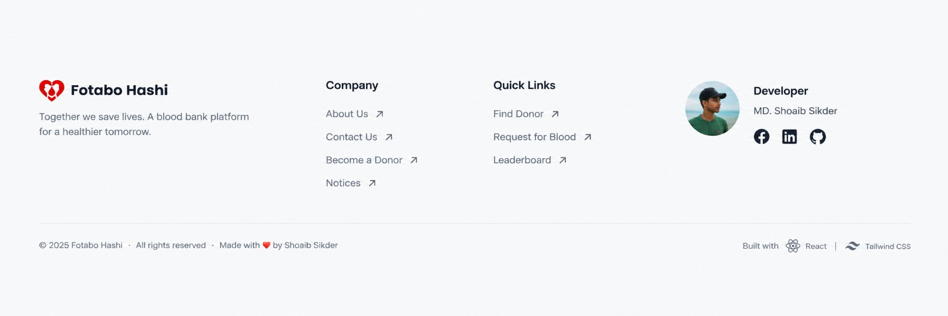
Figure F.1: Footer reference supplied by project owner

Appendix G: Repository Checks and CI Workflow
Workflow job | Configured commands / gates
Backend | Ruff check; Black --check; pip-audit -r requirements.txt; python manage.py check; pytest; python manage.py spectacular --validate --fail-on-warn.
Backend CI services | PostgreSQL 17 + Redis 7 services; test settings; restricted database role created for app tests.
Frontend | npm ci; npm audit --audit-level=moderate; npm run lint; npm run build.
Triggers | GitHub Actions push and pull_request triggers; concurrency cancels prior run for same group.
Status statement | This describes workflow configuration only. Latest CI pass/fail state was not asserted in this report.

Appendix H: Key Repository Modules
Path | Responsibility
backend/api/v1/urls.py | Versioned API includes route namespaces and schema/docs/health endpoints.
backend/config/settings/base.py | Installed apps, middleware, PostgreSQL URL validation, JWT config, DRF, CORS/CSRF, cache, storage and OpenAPI.
backend/apps/accounts/ | Custom user, email login/register/reset, JWT cookies and CSRF.
backend/apps/profiles/ | Profile model, validators, signals, services and own-profile API.
backend/apps/donors/ | Profile-based available donor filters/query/serializer.
backend/apps/blood_requests/ | Request model, filter, owner rules, transitions, notifications and summary.
backend/apps/leaderboard/ | DonationRecord, DonationCountReview and ranking.
backend/apps/content/ | Organization, notices, founding-member public content and cache.
backend/apps/notifications/ | Event types, notification payload, list/read/read-all.
backend/apps/administration/ | Admin overview, user, donation, review, request, content and audit views.
backend/apps/audit/ | Audit event model and trusted audit service.
backend/infrastructure/database/rls/ | PostgreSQL RLS identity context and cleanup.
backend/infrastructure/storage/ | Local/Supabase Storage adapters and UUID upload paths.
frontend/src/app/router.jsx | Lazy route definitions and role guards.
frontend/src/services/apiClient.js | Fetch wrapper, cookies, CSRF, refresh retry, errors and cache invalidation.
frontend/src/services/endpointConfig.js | Frontend URL map for backend endpoints.
frontend/src/contexts/ | Auth and language state.
frontend/src/components/layout/ | Public/member/admin shells, navigation and footer.
frontend/src/features/ | Page-level features.
frontend/src/i18n/locales/ | English and Bangla JSON dictionaries.
frontend/src/styles/design-tokens.css | Color, radius, shadow and neumorphic tokens.
.github/workflows/ci.yml | Automated backend/frontend checks.

Appendix I: Known Gaps and Decisions for Project Owner
Decision ID | Question / gap | Decision needed
G-01 | Should member bottom navigation include Settings directly? Current four tabs omit it. | Confirm item order and whether Notifications/Profile need dedicated tabs.
G-02 | Should approved donation count appear in dashboard identity card? | Confirm placement and whether user needs both self-reported and approved counts.
G-03 | Should member profiles support photo upload? Current model intentionally has no profile image. | Approve storage/privacy/data model change if real avatars are required.
G-04 | Should Services and Founders become nav destinations? | Confirm content and page/anchor routes; current public nav links to About/Active Members/Notices only.
G-05 | What is the approved donor phone/location visibility policy? | Confirm consent, visibility and contact method; current authenticated donor API exposes phone and location.
G-06 | Are needed-by time, hospital name, patient/contact details required? | Confirm fields, retention, consent and privacy before extending request model/API.
G-07 | Should user mobile bottom nav include notifications? | Current NotificationCenter is placed in header; bottom nav has no notification tab.
G-08 | Should notices have separate detail pages? | Current public notice list is a homepage section only.
G-09 | Should user-profile donation history be exposed? | DonationRecord exists; current user UI exposes counts/review status, not a history list.
G-10 | Should footer bottom strip include Made-with and technology credit? | Current footer code has dynamic copyright line but not full screenshot strip.

Appendix J: Glossary
Term | Meaning
USER | Regular authenticated member role.
ADMIN | Administrator role checked by IsAdminRole.
Profile | One-to-one account profile containing name/contact/group/location/availability/count fields.
Donor | A member whose Profile is marked available for donation; this does not establish clinical eligibility.
BloodRequest | A member-created request with group, quantity, location, description and status.
DonationRecord | Administrator-recorded event of a completed donation.
DonationCountReview | Workflow to approve/reject member-submitted donation count changes.
Approved donation count | Server-maintained count used by leaderboard.
RLS | PostgreSQL Row-Level Security.
HttpOnly cookie | Cookie inaccessible to browser JavaScript.
CSRF | Cross-Site Request Forgery protection.
Supabase Storage | Object storage used for active-member photos in production.
DRF | Django REST Framework.
ERD | Entity Relationship Diagram.
RTM | Requirements Traceability Matrix.
TBD | To be decided or verified.

Appendix K: Verification Statement
This report was generated from source inspection of the repository main revision identified on the cover. It documents current source behavior, not a live production penetration test or a fresh execution of the CI pipeline. All repository-test labels identify test source coverage; they do not imply a successful test run. Deployment health, hosted data, live service quotas and actual user experience on physical devices must be checked in the deployment environment before release.

